ASSIGNMENT 2

PMC 240 (Winter 2022)

**SUBMITTED TO: professor Stanley UKAH**

**SUBMITTED BY group 1:**

AKRITI SINGH – 126774207

afreen – 142851211

Afaounodden Ahmed Mohammed – 104492210

RINI GEORGE- 137051215

**TABLE OF CONTENTS**

1. AUTOMATION TOOL ……………………………………………………....…………..2

SELENIUM IDE……………………………………............................…………..2

INSTALLATION………………..…………………............................…………..2

1. AREAS TO BE TESTED…………………………………………………………………4
2. TEST CASES….…………………………...…………………………………………......5
3. MANUAL TEST EXECUTION…………………………………………………………14
4. AUTOMATION TEST EXECUTION…………………………………………………..19
5. TEST REPORT………………………………………………………………………….30
6. **AUTOMATION TOOL – INSTALLATION**

**SELENIUM IDE:**

IDE is an abbreviation for Integrated Development Environment. It's the most basic tool in the Selenium Suite. It's a Firefox add-on that generates automation test suites by utilizing the record and playback functions. This tool can be worked on by a resource with no development experience. The features of this tool include:

* Testcases are automatically recorded.
* Functionality through the use of the built-in assertion.
* Aids in the visual testing of various software applications.

**INSTALLATION:**

Launch the browser Firefox and navigate to https://addons.mozilla.org/en-US/firefox/addon/selenium-ide/: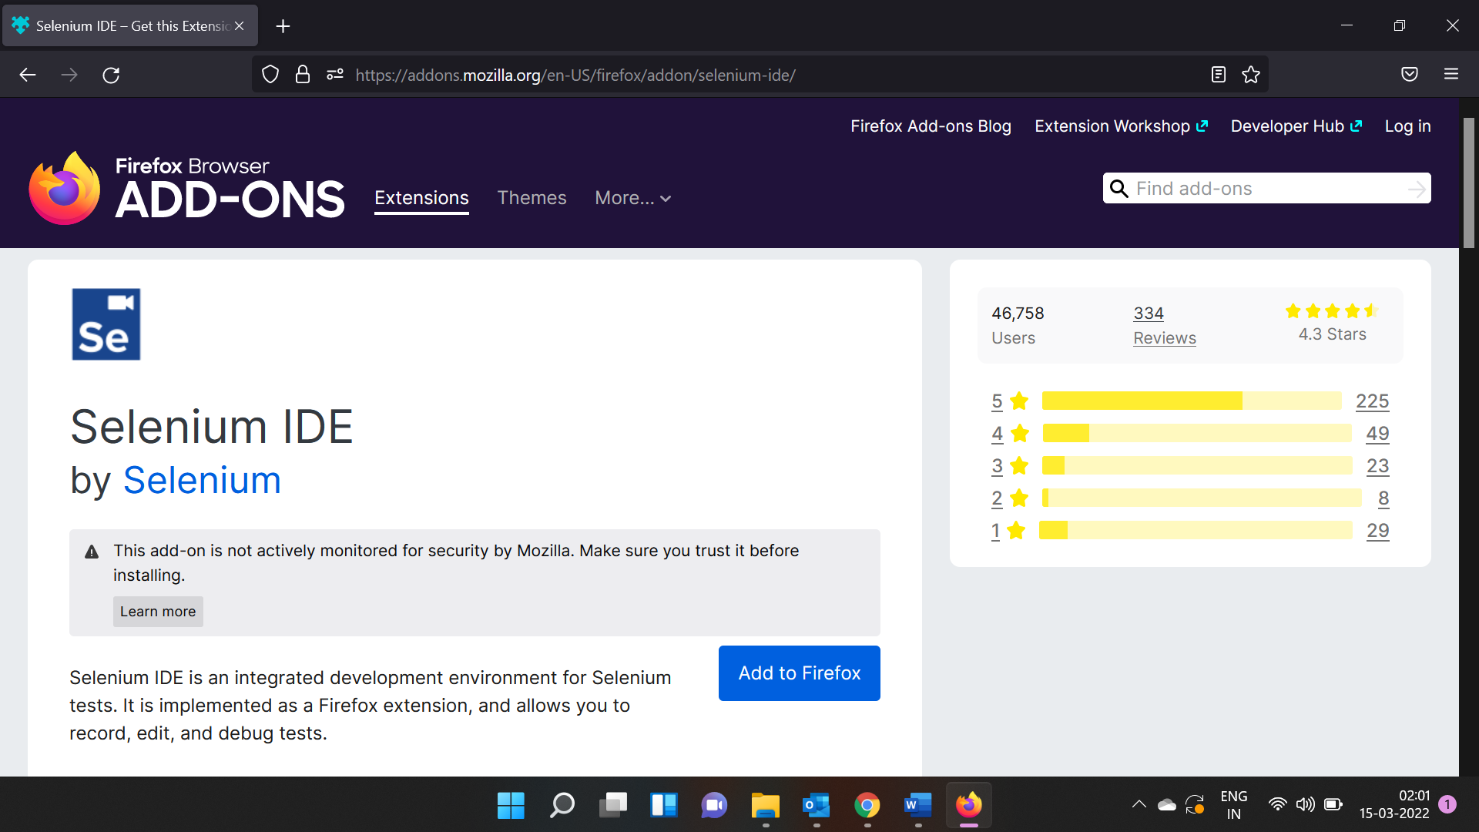

To add the Selenium IDE extension to Firefox, click ‘Add to Firefox’ and then the Add button:

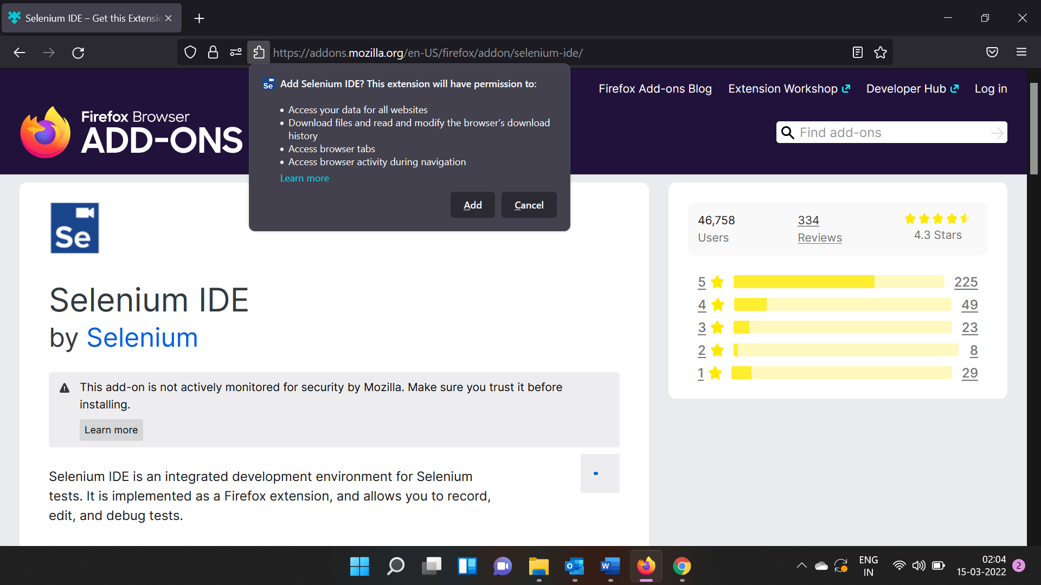

Selenium IDE extension is installed successfully:

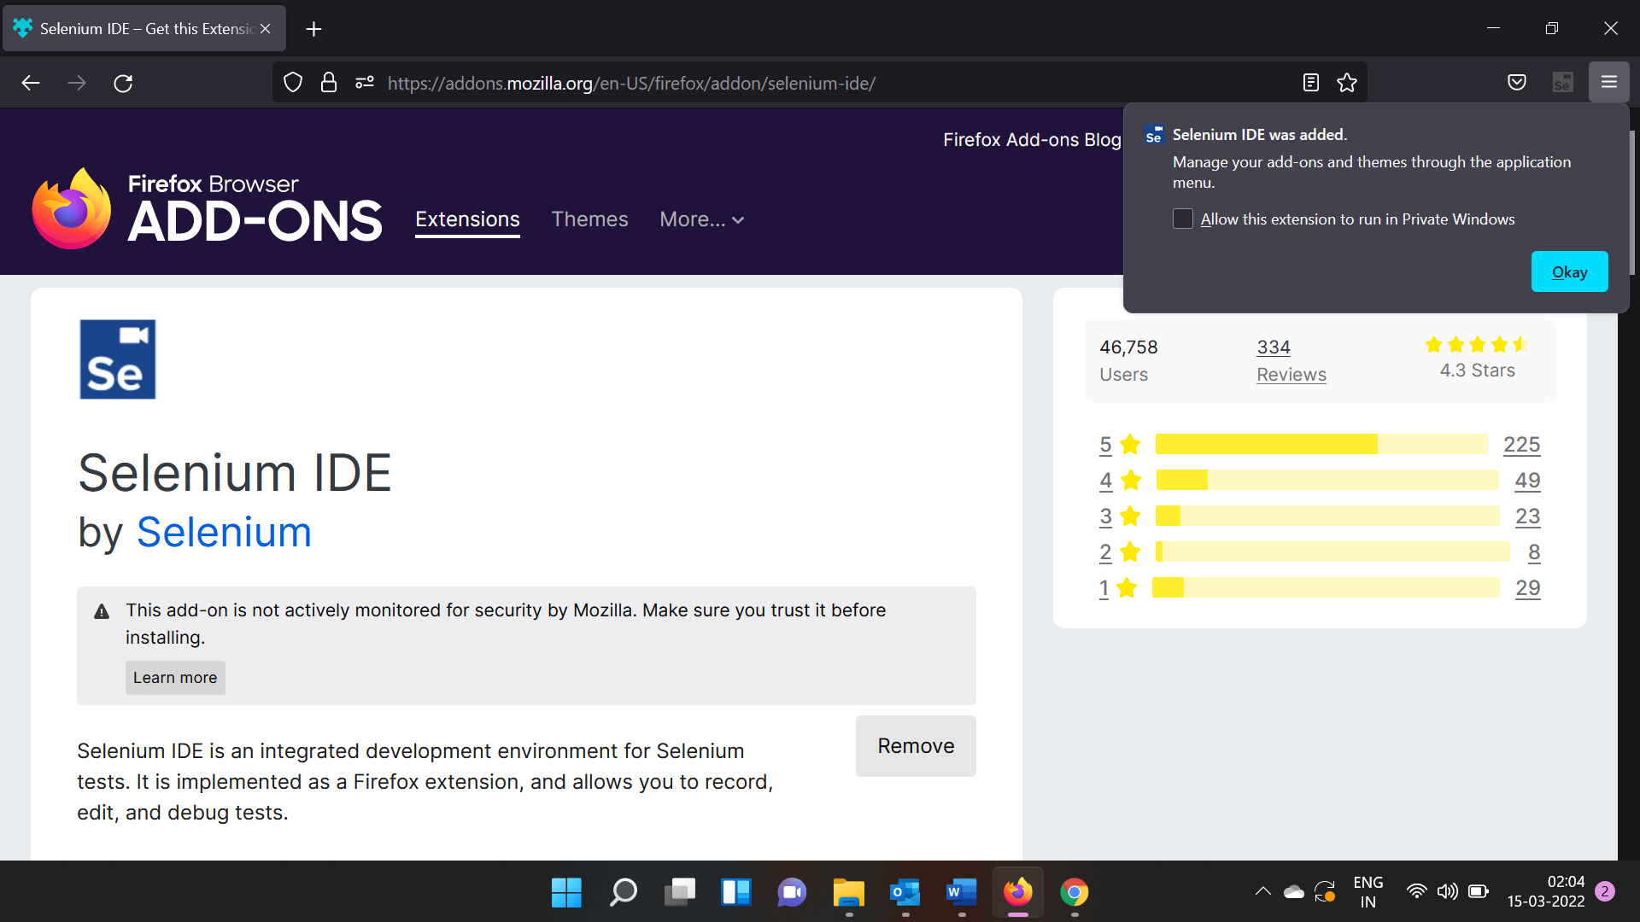

1. **AREAS TO BE TESTED**

**Product Store** is an electronic gadget store, offering online options for customers to fulfill all of their electronic needs at one location. Customers can purchase products such as laptops, mobile phones, and monitors at the store. Customers need to register on the website with a valid username and password before they can make a purchase. A customer can browse through different products before adding the desired one to the cart and checking out. Tests must guarantee that data collected from customers is authentic and secure. Testing is an important step in making sure data integrity and a better customer experience on the website.

Testing will take place in the following areas on the e-commerce website:

* 1. **User Registration:** To ensure that all the fields have valid inputs, and the username field does not accept duplicate values, validation testing of the registration process needs to be conducted. There is a high level of importance in this area to ensure that only legitimate users register.
  2. **User Login:** It is imperative to perform authentication testing on all fields that take login information as input, ensuring that only authorized users have access to their respective accounts. The level of criticality in this area is high. It ensures customer security and data protection.
  3. **Order Placement:** The process of verification must be performed to ensure that the appropriate products are added to the cart. In addition, it must be ensured that the place order button is successfully clicked so that the order can be placed. The operation of this area is moderately critical since it can disrupt the functioning of the company if it does not work correctly.
  4. **Product Catalogue:** For product placement within their corresponding categories, verification testing is required.
  5. **Connecting with customer support:** To make sure that only customers with valid email addresses have access to customer service through written communication, **validation testing** is required.

1. **TEST CASES**

**USER REGISTRATION:**

|  |  |
| --- | --- |
| Test Case ID | TCDB-1 |
| Test Case Summary | Required Field – Mandatory error validation |
| Test Cases (Requirement) | Check the required fields by not filling in any data |
| Preconditions | The user can access the site |
| Test Procedure/Steps | * Do not enter any value in the field. * Click on the Register button. |
| Test Data | N/a |
| Expected Result | It should show a mandatory symbol (*) on mandatory fields. |
| Actual Result | An error message is displayed to enter mandatory fields. |
| Remarks | NIL |
| Post Conditions | Users should be able to enter valid data |
| Status | Pass |
| Created By | **AFREEN** |
| Date of Creation | 04-04-2022 |
| Test Environment | TENV7 |

|  |  |
| --- | --- |
| Test Case ID | TCDB-2 |
| Test Case Summary | Valid Data validation |
| Test Cases (Requirement) | Users should register by filling in all the required fields |
| Preconditions | The user can access the site |
| Test Procedure/Steps | * Enter valid values in the required fields. * Click the Register button. |
| Test Data | N/a |
| Expected Result | The user should be registered successfully along with a message displayed and a mail notification send to the user. |
| Actual Result | A successful registration message is displayed and mail is sent to the user |
| Remarks | NIL |
| Post Conditions | The user should be able to proceed further with the navigation |
| Status | Pass |
| Created By | **AFREEN** |
| Date of Creation | 04-04-2022 |
| Test Environment | TENV7 |

|  |  |
| --- | --- |
| Test Case ID | TCDB-3 |
| Test Case Summary | Validating email fields with invalid data |
| Test Cases (Requirement) | Verifying whether the user can enter an invalid email id and not able to further proceed |
| Preconditions | The user can access the site |
| Test Procedure/Steps | * Enter Invalid Emails * Click on the Register Button. |
| Test Data | testAmgmail.com  test@gmailcom |
| Expected Result | An error message should be displayed to enter a valid email address |
| Actual Result | An error message is displayed to enter a valid email id |
| Remarks | NIL |
| Post Conditions | Users should be able to enter valid data |
| Status | Pass |
| Created By | **AFREEN** |
| Date of Creation | 04-04-2022 |
| Test Environment | TENV7 |

|  |  |
| --- | --- |
| Test Case ID | TCDB-4 |
| Test Case Summary | Valid email data validation |
| Test Cases (Requirement) | Users should be able to enter valid email id and proceed further |
| Preconditions | The user can access the site |
| Test Procedure/Steps | Enter valid Emails  Click on the Register Button. |
| Test Data | [test.44@gmail.com](mailto:1.test.44@gmail.com)  [text@gmail.com](mailto:2.text@gmail.com) |
| Expected Result | The user can proceed further when entered a valid email address |
| Actual Result | The user can proceed further with a valid email address |
| Remarks | NIL |
| Post Conditions | The user should be able to proceed further with the navigation |
| Status | Pass |
| Created By | **AFREEN** |
| Date of Creation | 04-04-2022 |
| Test Environment | TENV7 |

|  |  |
| --- | --- |
| Test Case ID | TCDB-5 |
| Test Case Summary | Password filed validation – Word length |
| Test Cases (Requirement) | Check the password limit when entering values less than min |
| Preconditions | The user can access the site |
| Test Procedure/Steps | * Enter a value that is alphanumeric but less than 8. * Click on the Register button |
| Test Data | Test |
| Expected Result | An error message should be displayed to enter a valid password. |
| Actual Result | The user is able to view the error message to enter a valid password |
| Remarks | NIL |
| Post Conditions | Users should be able to enter valid data |
| Status | Pass |
| Created By | **AFREEN** |
| Date of Creation | 04-04-2022 |
| Test Environment | TENV7 |

|  |  |
| --- | --- |
| Test Case ID | TCDB-6 |
| Test Case Summary | Password filed validation – Word length |
| Test Cases (Requirement) | Check the password limit when entering a value greater than the max |
| Preconditions | The user is able to access the site |
| Test Procedure/Steps | * Enter alphanumeric value but more than 32. * Click on the Register button |
| Test Data | Any Random string with numbers |
| Expected Result | An error message should be displayed to enter a valid password. |
| Actual Result | Users should be able to enter valid data |
| Remarks | NIL |
| Post Conditions | The user should be able to proceed further with the navigation |
| Status | Pass |
| Created By | **AFREEN** |
| Date of Creation | 04-04-2022 |
| Test Environment | TENV7 |

|  |  |
| --- | --- |
| Test Case ID | TCDB-7 |
| Test Case Summary | Password filed validation – Numeric only |
| Test Cases (Requirement) | Check the password when passing only numbers |
| Preconditions | The user is able to access the site |
| Test Procedure/Steps | * Enter a value in numbers which is between 8-32 * Click on the Register button |
| Test Data | 12345678 |
| Expected Result | An error message should be displayed to enter a valid password. |
| Actual Result | The user is able to view the error message to enter a valid password |
| Remarks | NIL |
| Post Conditions | Users should be able to enter valid data |
| Status | Pass |
| Created By | **AFREEN** |
| Date of Creation | 04-04-2022 |
| Test Environment | TENV7 |

|  |  |
| --- | --- |
| Test Case ID | TCDB-8 |
| Test Case Summary | Password filed validation with valid data |
| Test Cases (Requirement) | Check the password when passing valid data |
| Preconditions | The user is able to access the site |
| Test Procedure/Steps | * Enter the value in alphanumeric which is between 8-32 * Click on the Register button |
| Test Data | test123456 |
| Expected Result | The user should be able to register and proceed further |
| Actual Result | The user is able to register and proceed further |
| Remarks | NIL |
| Post Conditions | The user should be able to proceed further with the navigation |
| Status | Pass |
| Created By | **AFREEN** |
| Date of Creation | 04-04-2022 |
| Test Environment | TENV7 |

|  |  |
| --- | --- |
| Test Case ID | TCDB-9 |
| Test Case Summary | Username field validation with invalid data |
| Test Cases (Requirement) | Check all valid usernames |
| Preconditions | The user is able to access the site |
| Test Procedure/Steps | * Enter an invalid username with duplicate values * Enter the correct password * Click on Login Button |
| Test Data |  |
| Expected Result | An error message should be displayed to enter a valid username. |
| Actual Result | The user is able to view the error message to enter a valid username |
| Remarks | NIL |
| Post Conditions | Users should be able to enter valid data |
| Status | Pass |
| Created By | **AFREEN** |
| Date of Creation | 04-04-2022 |
| Test Environment | TENV7 |

|  |  |
| --- | --- |
| Test Case ID | TCDB-10 |
| Test Case Summary | Username filed validation with valid data |
| Test Cases (Requirement) | Check all valid usernames |
| Preconditions | The user is able to access the site |
| Test Procedure/Steps | * Enter a valid username * Click on Login Button |
| Test Data |  |
| Expected Result | The user should be able to register and proceed further |
| Actual Result | The user is able to register and proceed further |
| Remarks | NIL |
| Post Conditions | The user should be able to proceed further with the navigation |
| Status | Pass |
| Created By | **AFREEN** |
| Date of Creation | 04-04-2022 |
| Test Environment | TENV7 |

|  |  |
| --- | --- |
| Test Case ID | TCDB-11 |
| Test Case Summary | Check with no usernames and valid password |
| Test Cases (Requirement) | Check all valid usernames |
| Preconditions | The user is able to access the site |
| Test Procedure/Steps | * Enter a valid password * Do not enter a username * Click on Login Button |
| Test Data |  |
| Expected Result | An error message should be displayed informing us to enter a valid information |
| Actual Result | An error message is displayed |
| Remarks | NIL |
| Post Conditions | The user should be able to enter valid data and proceed further |
| Status | Pass |
| Created By | **AFREEN** |
| Date of Creation | 04-04-2022 |
| Test Environment | TENV7 |

**USER LOGIN:**

|  |  |
| --- | --- |
| Test Case ID | TCDB-12 |
| Test Case Summary | Check all valid usernames and invalid password |
| Test Cases (Requirement) | Check When passing a correct username and invalid password |
| Preconditions | The user is able to access the site |
| Test Procedure/Steps | * Enter a valid username * Enter an incorrect password * Click on Login Button |
| Test Data |  |
| Expected Result | Users should not log in and an error message should be shown |
| Actual Result | Error message shown |
| Remarks | NIL |
| Post Conditions | The user should be able to enter valid data and proceed further |
| Status | Pass |
| Created By | **AFREEN** |
| Date of Creation | 04-04-2022 |
| Test Environment | TENV7 |

|  |  |
| --- | --- |
| Test Case ID | TCDB-13 |
| Test Case Summary | Check all valid usernames and valid password |
| Test Cases (Requirement) | Check when passing the correct email and password |
| Preconditions | The user is able to access the site |
| Test Procedure/Steps | * Enter a valid username * Enter a valid password * Click on Login Button |
| Test Data |  |
| Expected Result | Users should log in and proceed further |
| Actual Result | A message with “User logged in” is shown |
| Remarks | NIL |
| Post Conditions | The user should be able to enter valid data and proceed further |
| Status | Pass |
| Created By | **AFREEN** |
| Date of Creation | 04-04-2022 |
| Test Environment | TENV7 |

|  |  |
| --- | --- |
| Test Case ID | TCDB-14 |
| Test Case Summary | Validating Welcome Email |
| Test Cases (Requirement) | Verify that new users should get the welcome email once after the login. |
| Preconditions | The user is able to access the site |
| Test Procedure/Steps | * Go to the Email. * Enter Login Email |
| Test Data |  |
| Expected Result | Users should get a welcome email on his/her email id. |
| Actual Result | Welcome email received |
| Remarks | NIL |
| Post Conditions | The user should be able to enter valid data and proceed further |
| Status | Pass |
| Created By | **AFREEN** |
| Date of Creation | 04-04-2022 |
| Test Environment | TENV7 |

**ORDER PLACEMENT AND PRODUCT CATALOGUE:**

|  |  |
| --- | --- |
| Test Case ID | TCDB-15 |
| Test Case Summary | Valid account/data is entered |
| Test Cases (Requirement) | Verify that new users should get the welcome email once after the login. |
| Preconditions | The user is able to access the site |
| Test Procedure/Steps | * An email address and a password are entered. * Matching search strings were found * Select an electronic item and add it to the shopping cart * Confirms shipping address and enter the “Place Order” button * Confirms credit card * Places the order |
| Test Data |  |
| Expected Result | The order should be placed |
| Actual Result | A message with “Order placed” is shown |
| Remarks | NIL |
| Post Conditions | The user should be able to enter valid data and proceed further |
| Status | Pass |
| Created By | **AFREEN** |
| Date of Creation | 04-04-2022 |
| Test Environment | TENV7 |

|  |  |
| --- | --- |
| Test Case ID | TCDB-16 |
| Test Case Summary | Product – search criteria |
| Test Cases (Requirement) | No products matching the search criteria were found |
| Preconditions | The user is able to access the site |
| Test Procedure/Steps | * Email address and password are entered. * Enter a search string that is not spelled correctly. * Verify event is logged. |
| Test Data |  |
| Expected Result | Order cannot be placed |
| Actual Result | A message with “Order cannot be placed” is shown |
| Remarks | NIL |
| Post Conditions | The user should be able to enter valid data and proceed further |
| Status | Pass |
| Created By | **AFREEN** |
| Date of Creation | 04-04-2022 |
| Test Environment | TENV7 |

**CONNECTING WITH CUSTOMER SUPPORT:**

|  |  |
| --- | --- |
| Test Case ID | TCDB-17 |
| Test Case Summary | Email Validation |
| Test Cases (Requirement) | Check the Email text field that has an Email address without @ symbol.  Check the Email text field that has a random string instead of a real email. |
| Preconditions | The user is able to access the site |
| Test Procedure/Steps | * Enter Invalid Emails * Click on the “send message” Button. |
| Test Data |  |
| Expected Result | It should show the validation message for a valid email |
| Actual Result | Error message “Enter valid email” is shown |
| Remarks | NIL |
| Post Conditions | The user should be able to enter valid data and proceed further |
| Status | Pass |
| Created By | **AFREEN** |
| Date of Creation | 04-04-2022 |
| Test Environment | TENV7 |

|  |  |
| --- | --- |
| Test Case ID | TCDB-18 |
| Test Case Summary | Email Validation |
| Test Cases (Requirement) | Check all the valid emails |
| Preconditions | The user is able to access the site |
| Test Procedure/Steps | * Enter valid Emails * Click on the “send message” Button. |
| Test Data |  |
| Expected Result | It should show a validation message as “enter contact name and message” |
| Actual Result | Error message “enter contact name and message” is shown |
| Remarks | NIL |
| Post Conditions | The user should be able to enter valid data and proceed further |
| Status | Pass |
| Created By | **AFREEN** |
| Date of Creation | 04-04-2022 |
| Test Environment | TENV7 |

|  |  |
| --- | --- |
| Test Case ID | TCDB-19 |
| Test Case Summary | Check valid contact name |
| Test Cases (Requirement) | Check all the valid emails |
| Preconditions | The user is able to access the site |
| Test Procedure/Steps | * Enter a valid contact name. |
| Test Data |  |
| Expected Result | Contact name should be displayed |
| Actual Result | Contact name is displayed |
| Remarks | NIL |
| Post Conditions | The user should be able to enter valid data and proceed further |
| Status | Pass |
| Created By | **AFREEN** |
| Date of Creation | 04-04-2022 |
| Test Environment | TENV7 |

|  |  |
| --- | --- |
| Test Case ID | TCDB-20 |
| Test Case Summary | Message validation |
| Test Cases (Requirement) | Check valid message |
| Preconditions | The user is able to access the site |
| Test Procedure/Steps | * Enter a message * Click “send message” |
| Test Data |  |
| Expected Result | “Message sent” should be displayed |
| Actual Result | “Message sent is displayed” |
| Remarks | NIL |
| Post Conditions | The user should be able to enter valid data and proceed further |
| Status | Pass |
| Created By | **AFREEN** |
| Date of Creation | 04-04-2022 |
| Test Environment | TENV7 |

1. **MANUAL TEST CASE EXECUTION**



|  |  |
| --- | --- |
| Test Case ID | TCDB-4 |
| Test Case Summary | Email Validation |
| Result | Fail (Due to accepting the wrong Email ID format) |

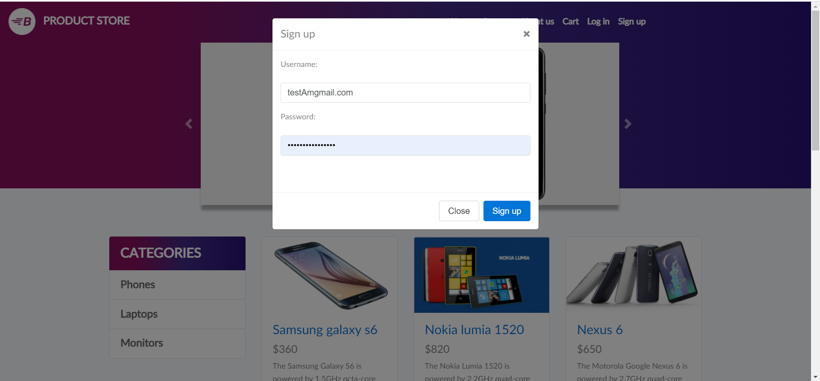



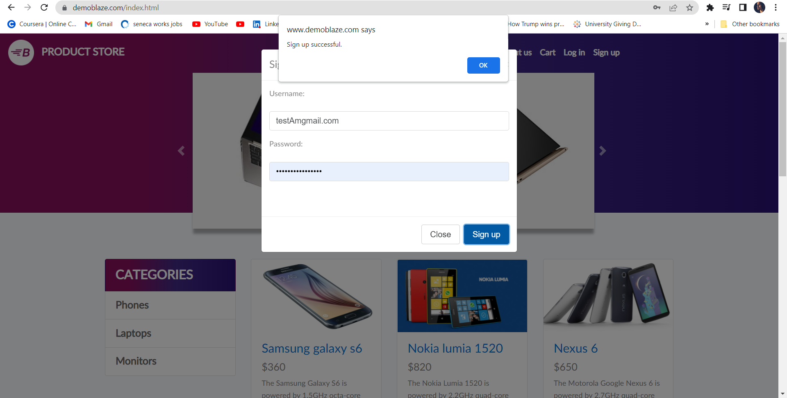



|  |  |
| --- | --- |
| Test Case ID | TCDB-8 |
| Test Case Summary | Password Validation |
| Result | Fail ( Due to accepting passwords without capital letters) |



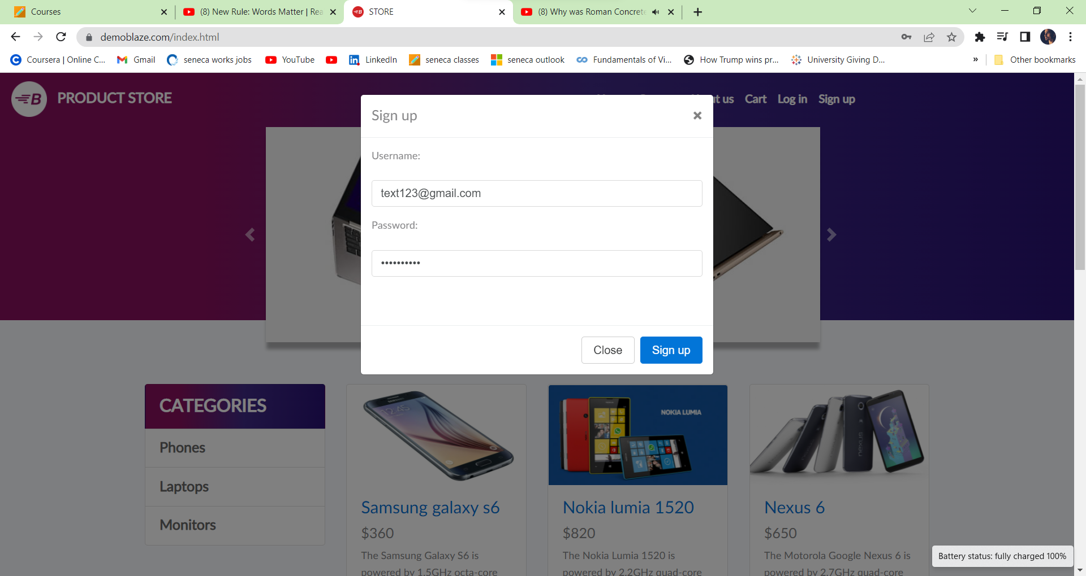

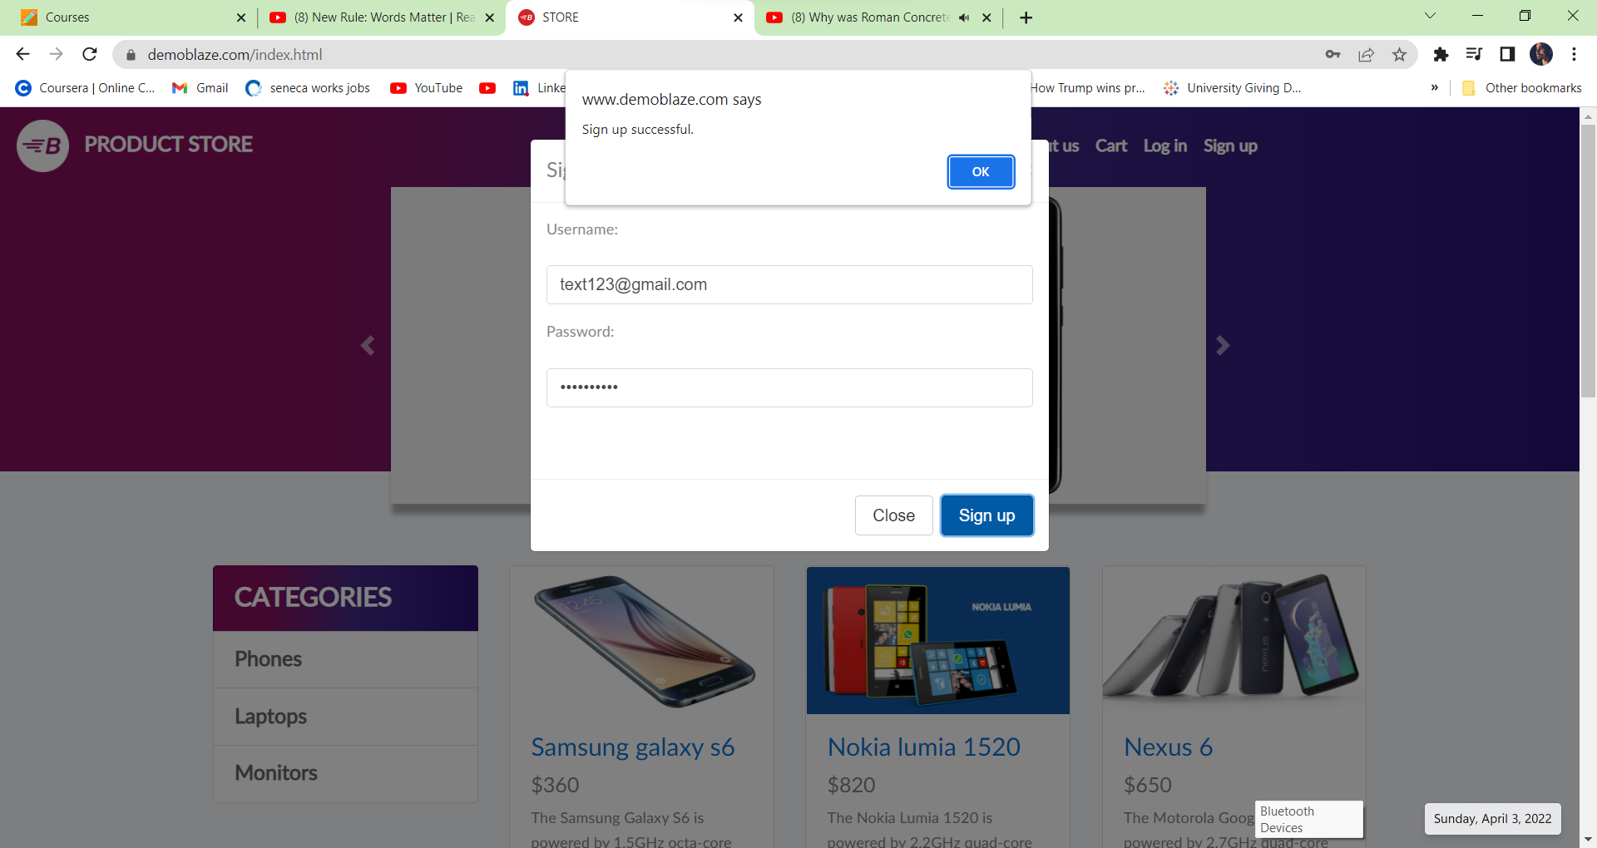

|  |  |
| --- | --- |
| Test Case ID | TCDB-10 |
| Test Case Summary | Password validation |
| Result | Pass |

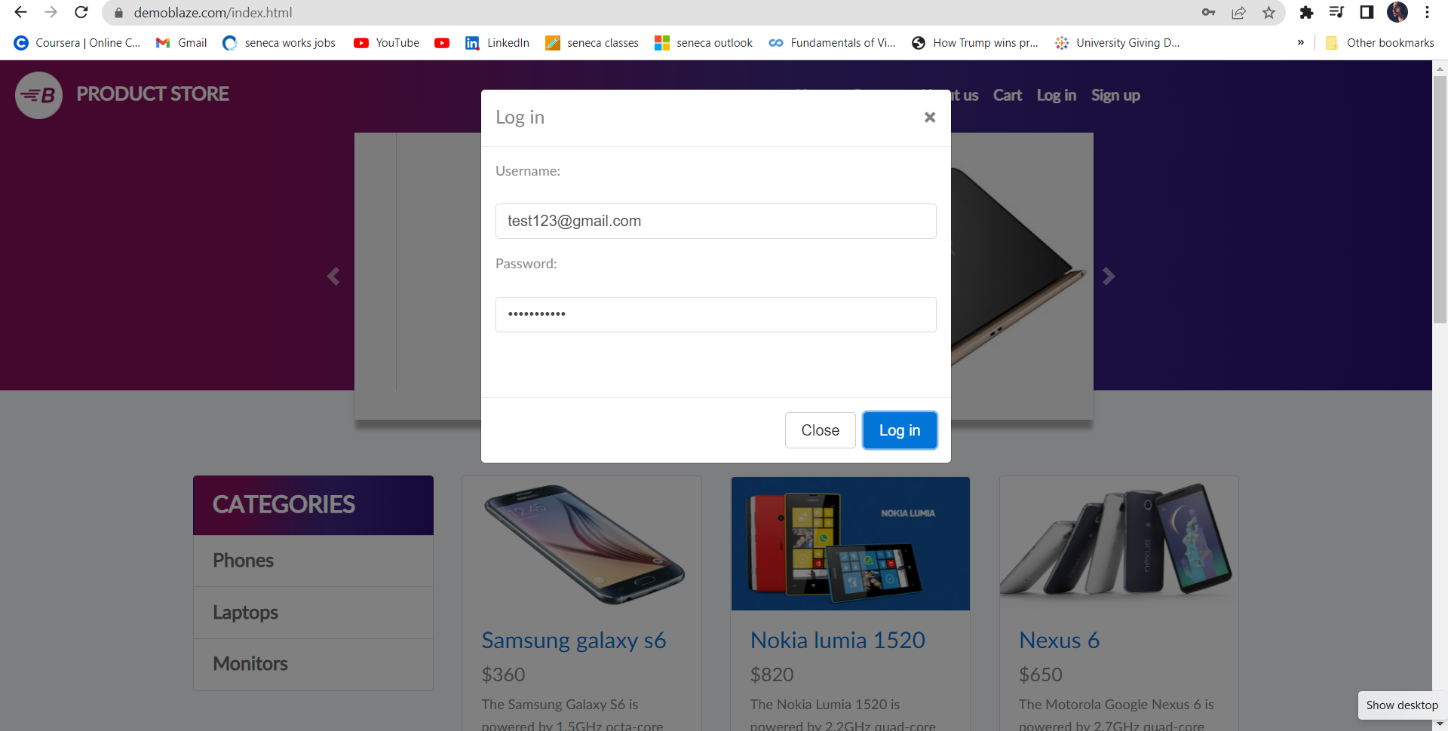

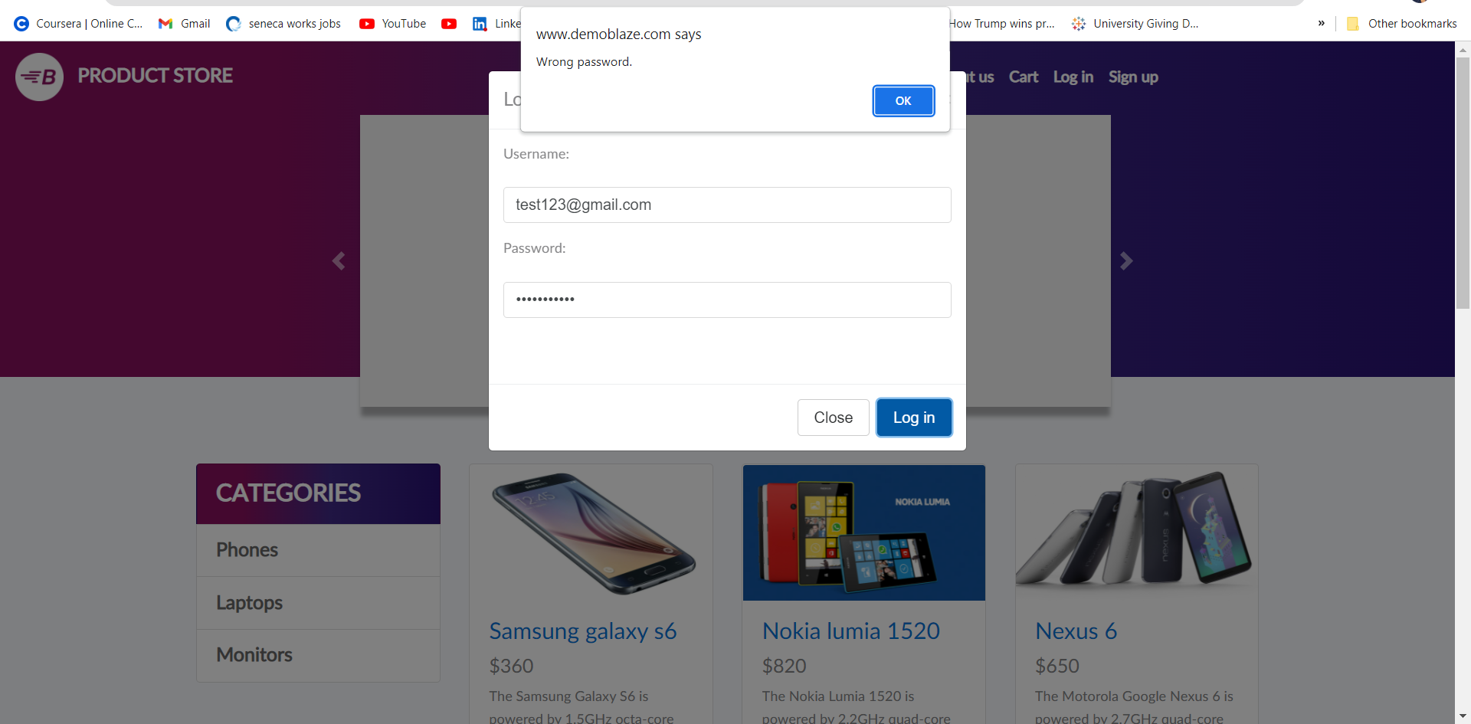

|  |  |
| --- | --- |
| Test Case ID | TCDB-1 |
| Test Case Summary | User Login |
| Result | Pass (As wrong password error Shown) |

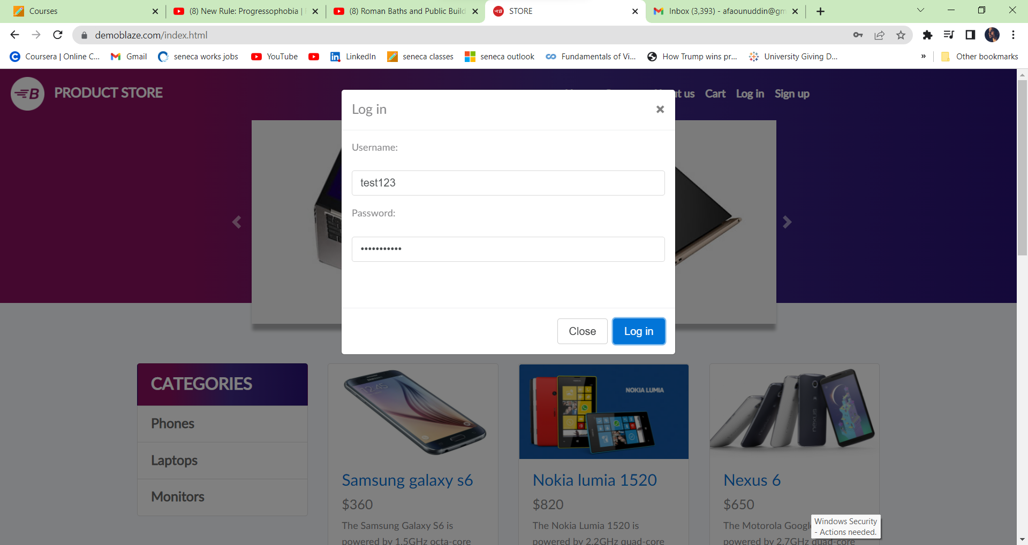



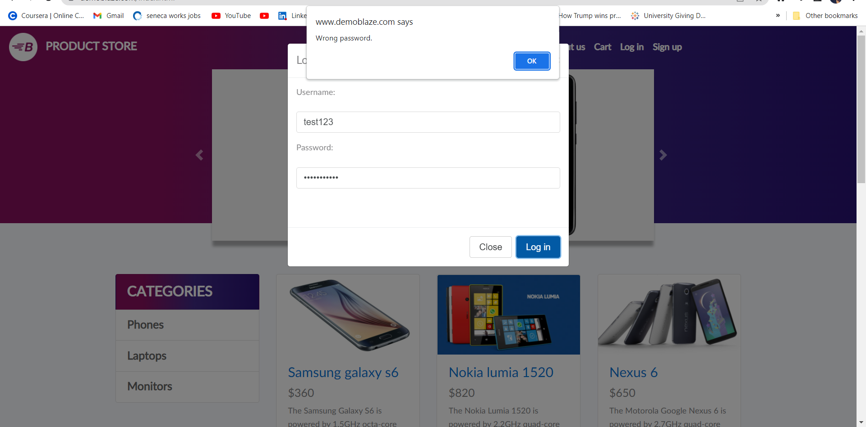



|  |  |
| --- | --- |
| Test Case ID | TCDB-5 |
| Test Case Summary | Welcome Email |
| Result | Fail ( Test case ID failed because Email was not sent ) |

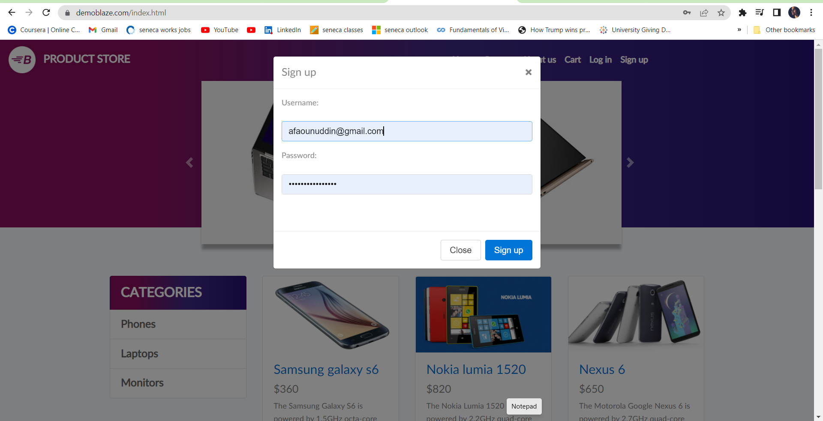

**Email Not received on the Registered Email ID**

1. **AUTOMATION TEST CASE EXECUTION**

|  |  |
| --- | --- |
| Test Case ID | TCDB-13 |
| Test Case Summary | Check all valid usernames and valid password |
| Result | Pass |

Click on the Selenium IDE icon:

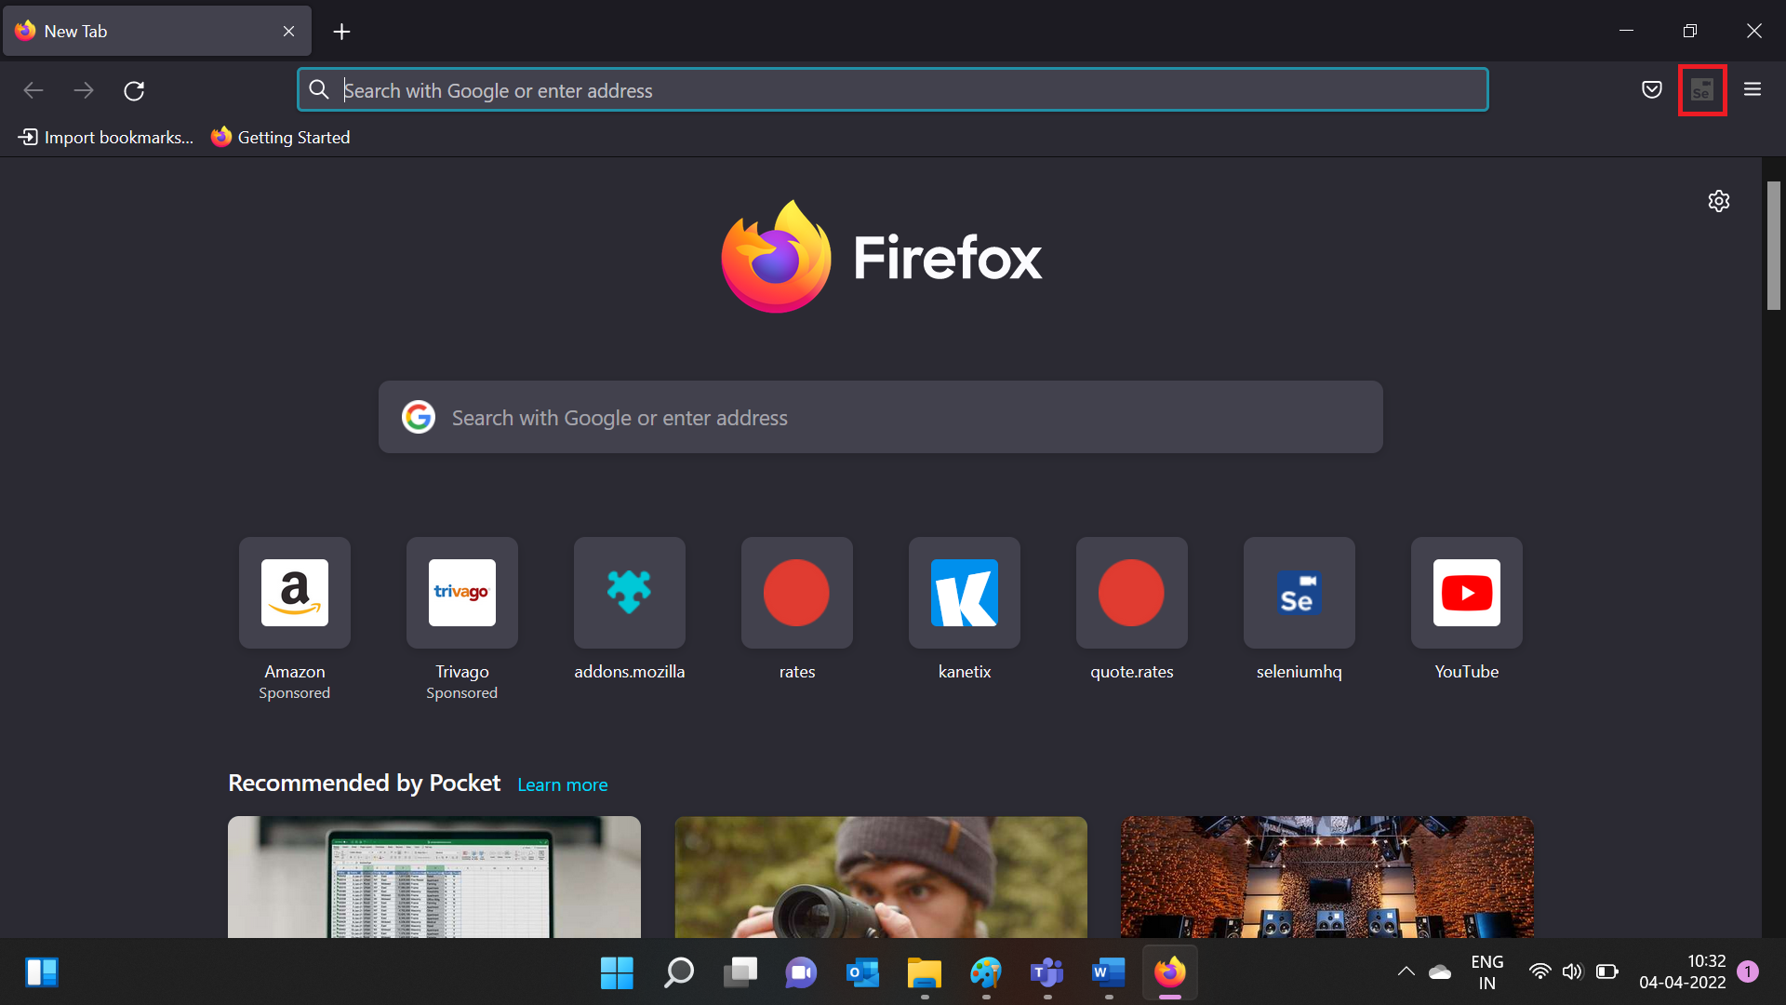

Welcome pop-up is displayed:

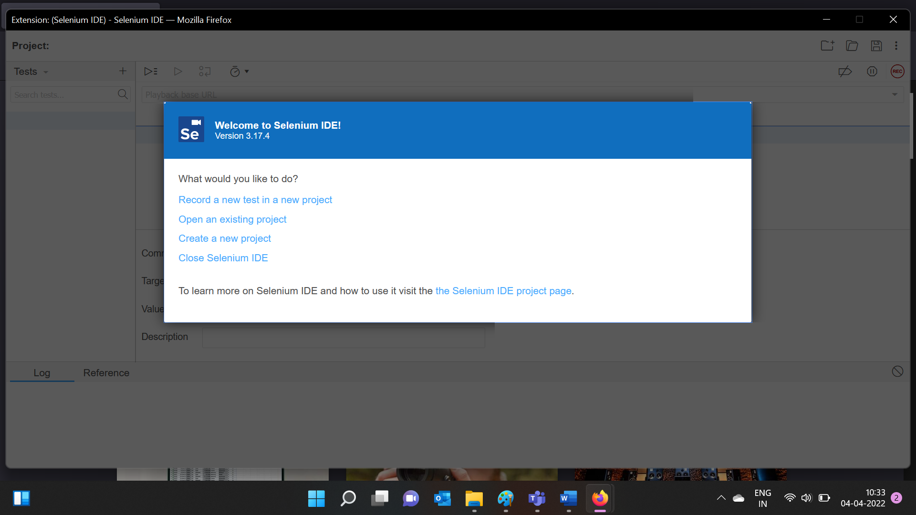

Click on create a new project:

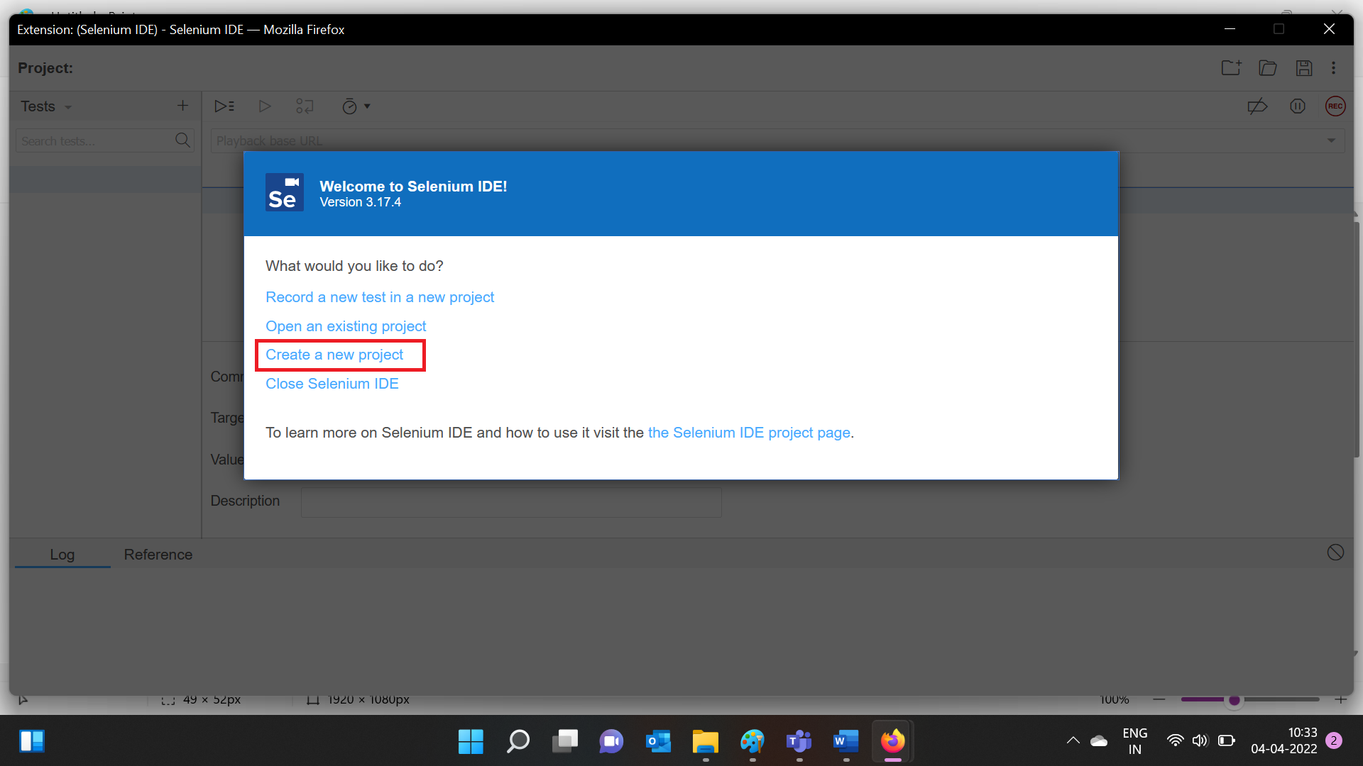

Enter a project name:

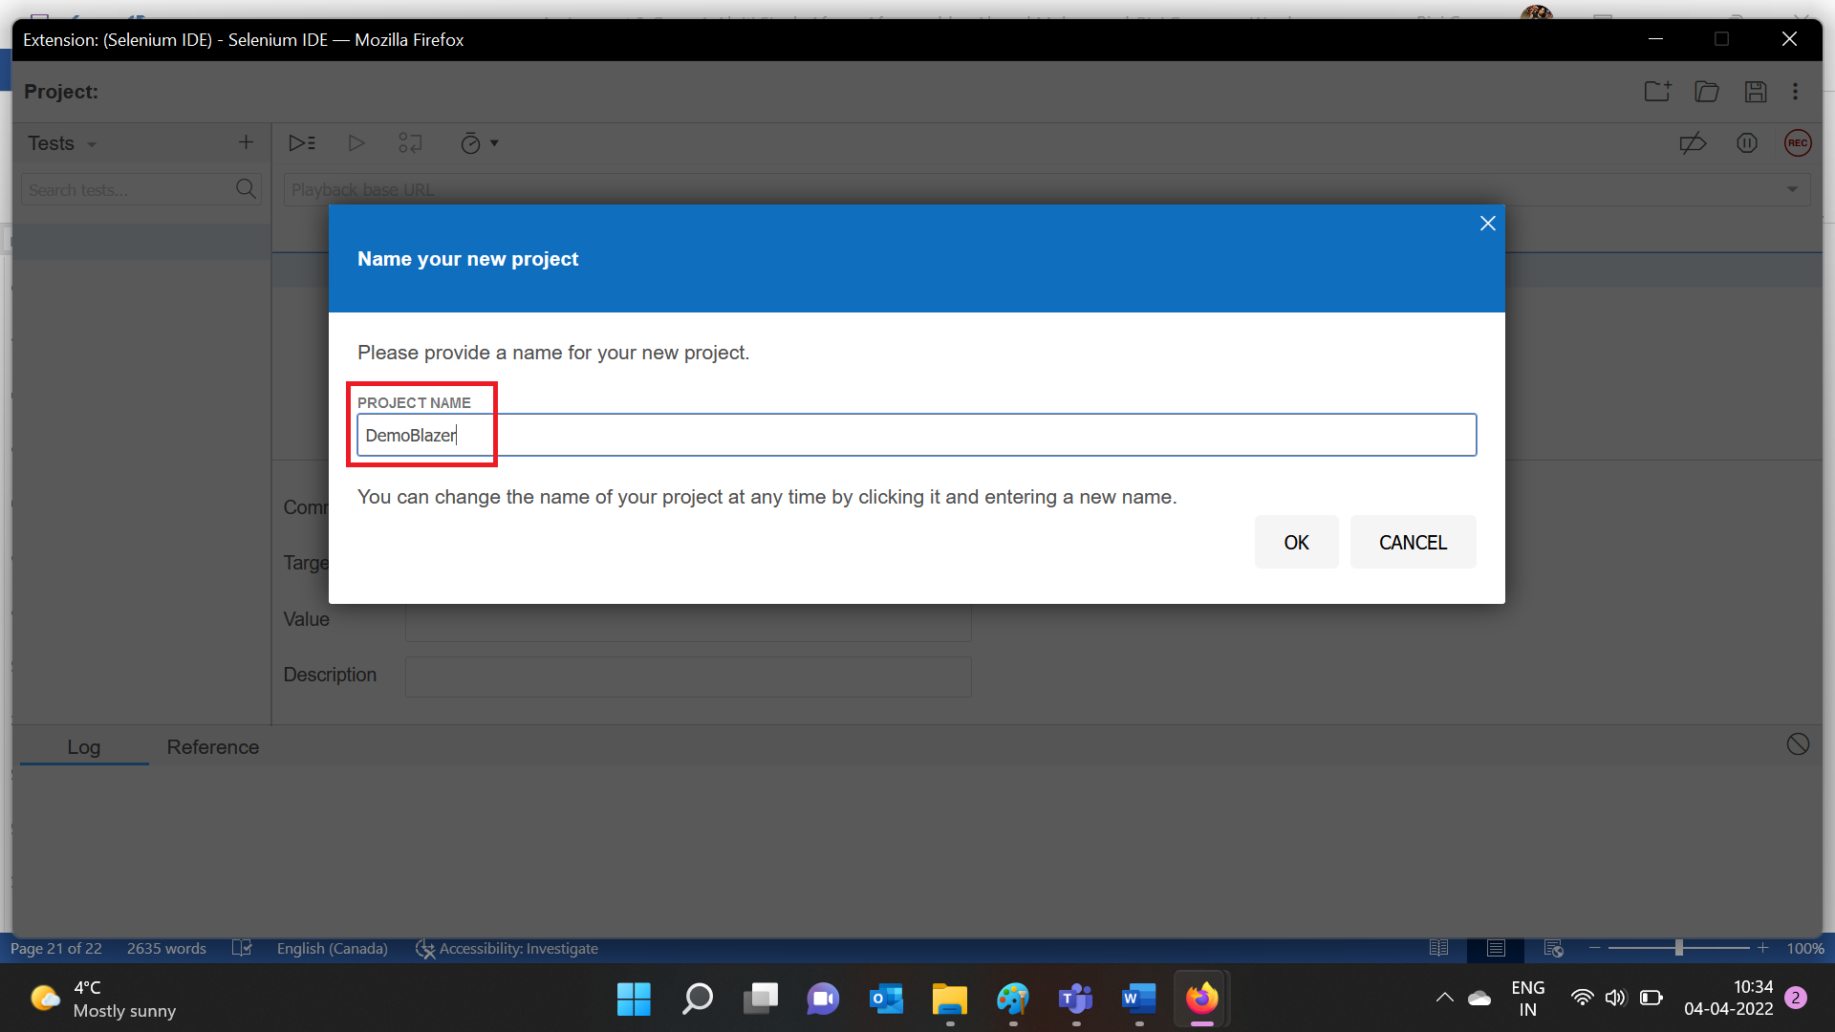

Click the ok button to proceed:

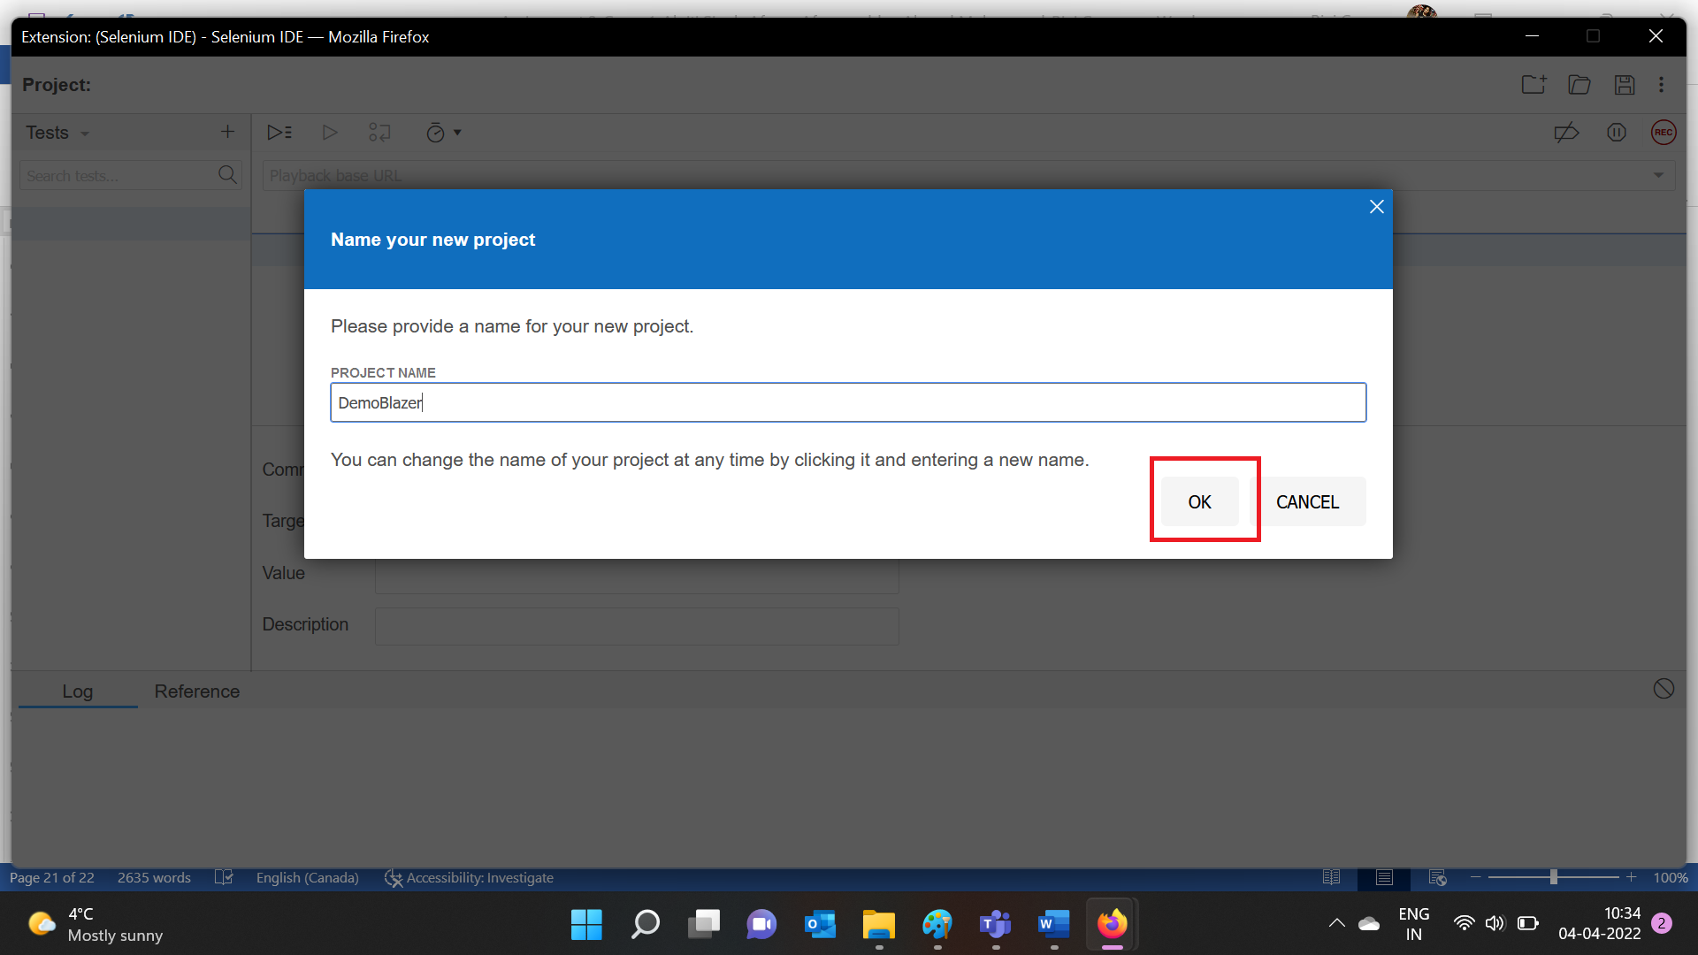

Create Test Case:

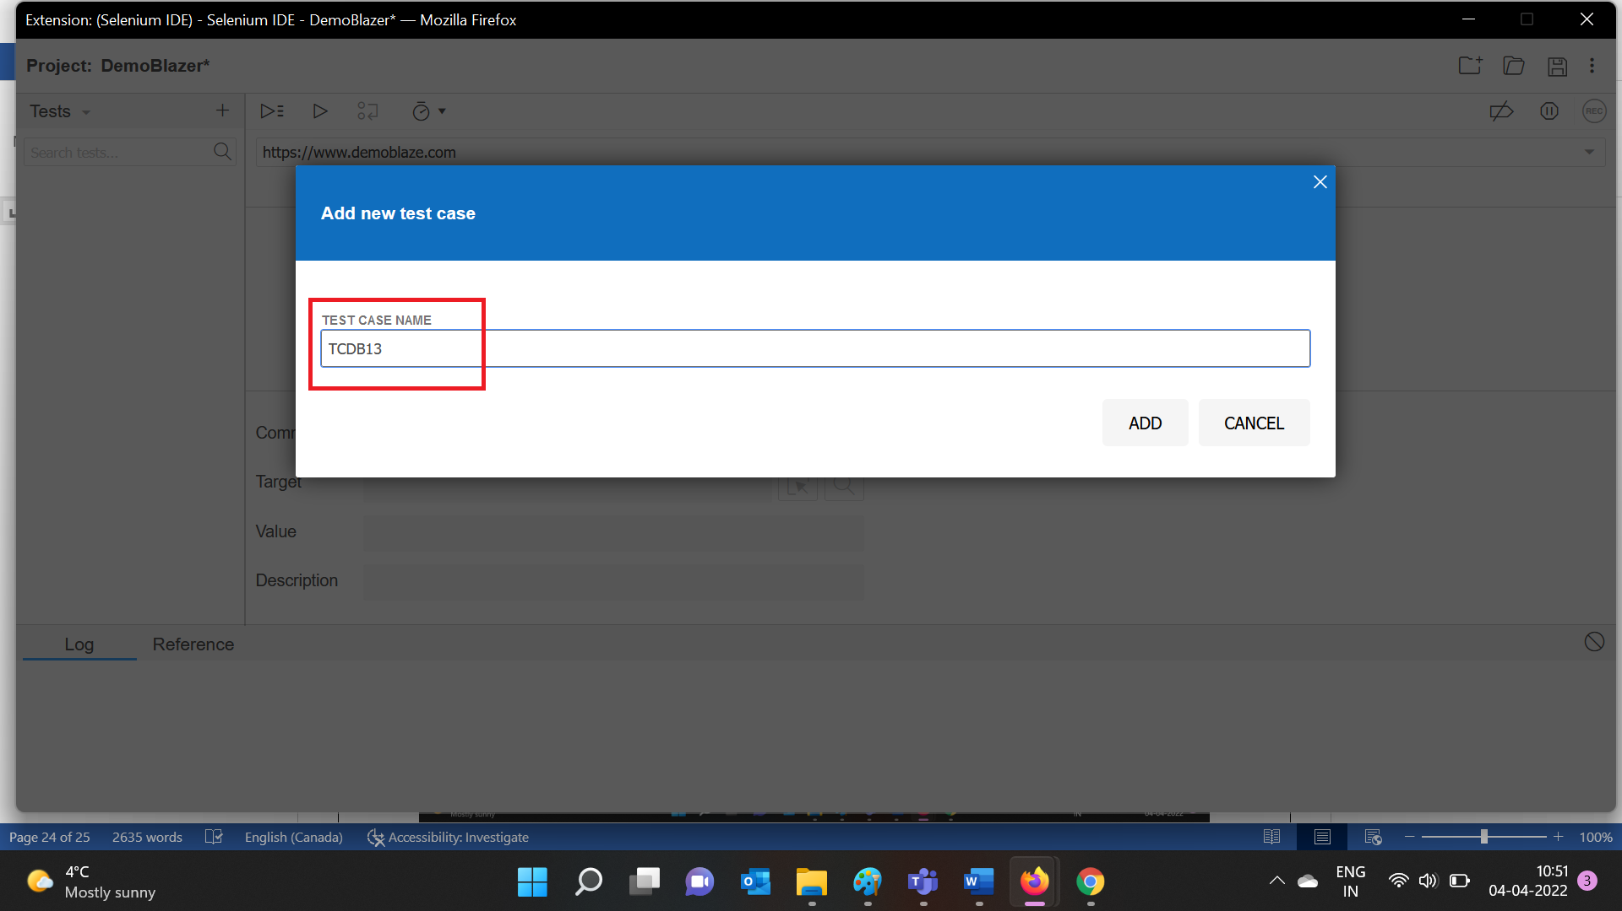

Click on Add button:

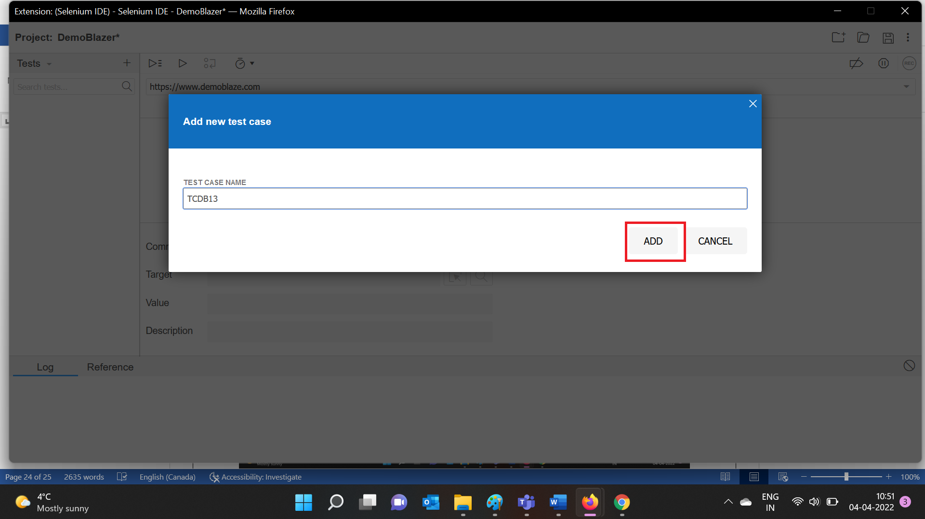

Test Case is created:

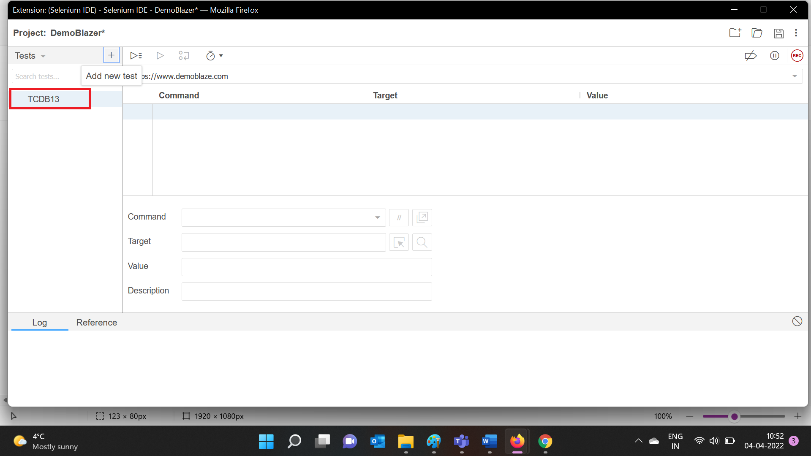

Click on the record button:

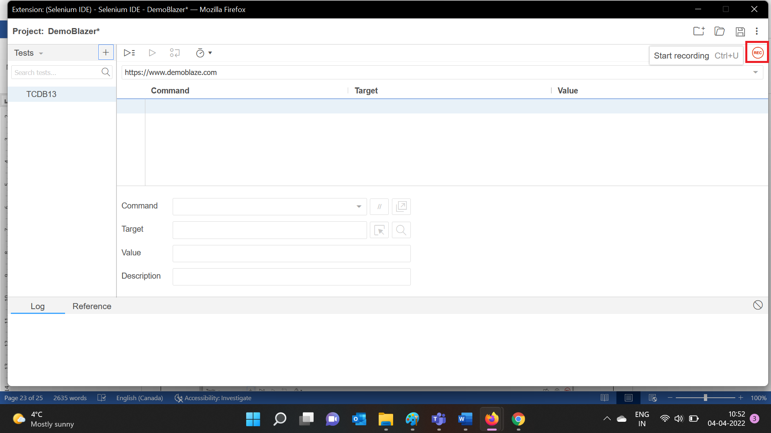

Enter the base URL:

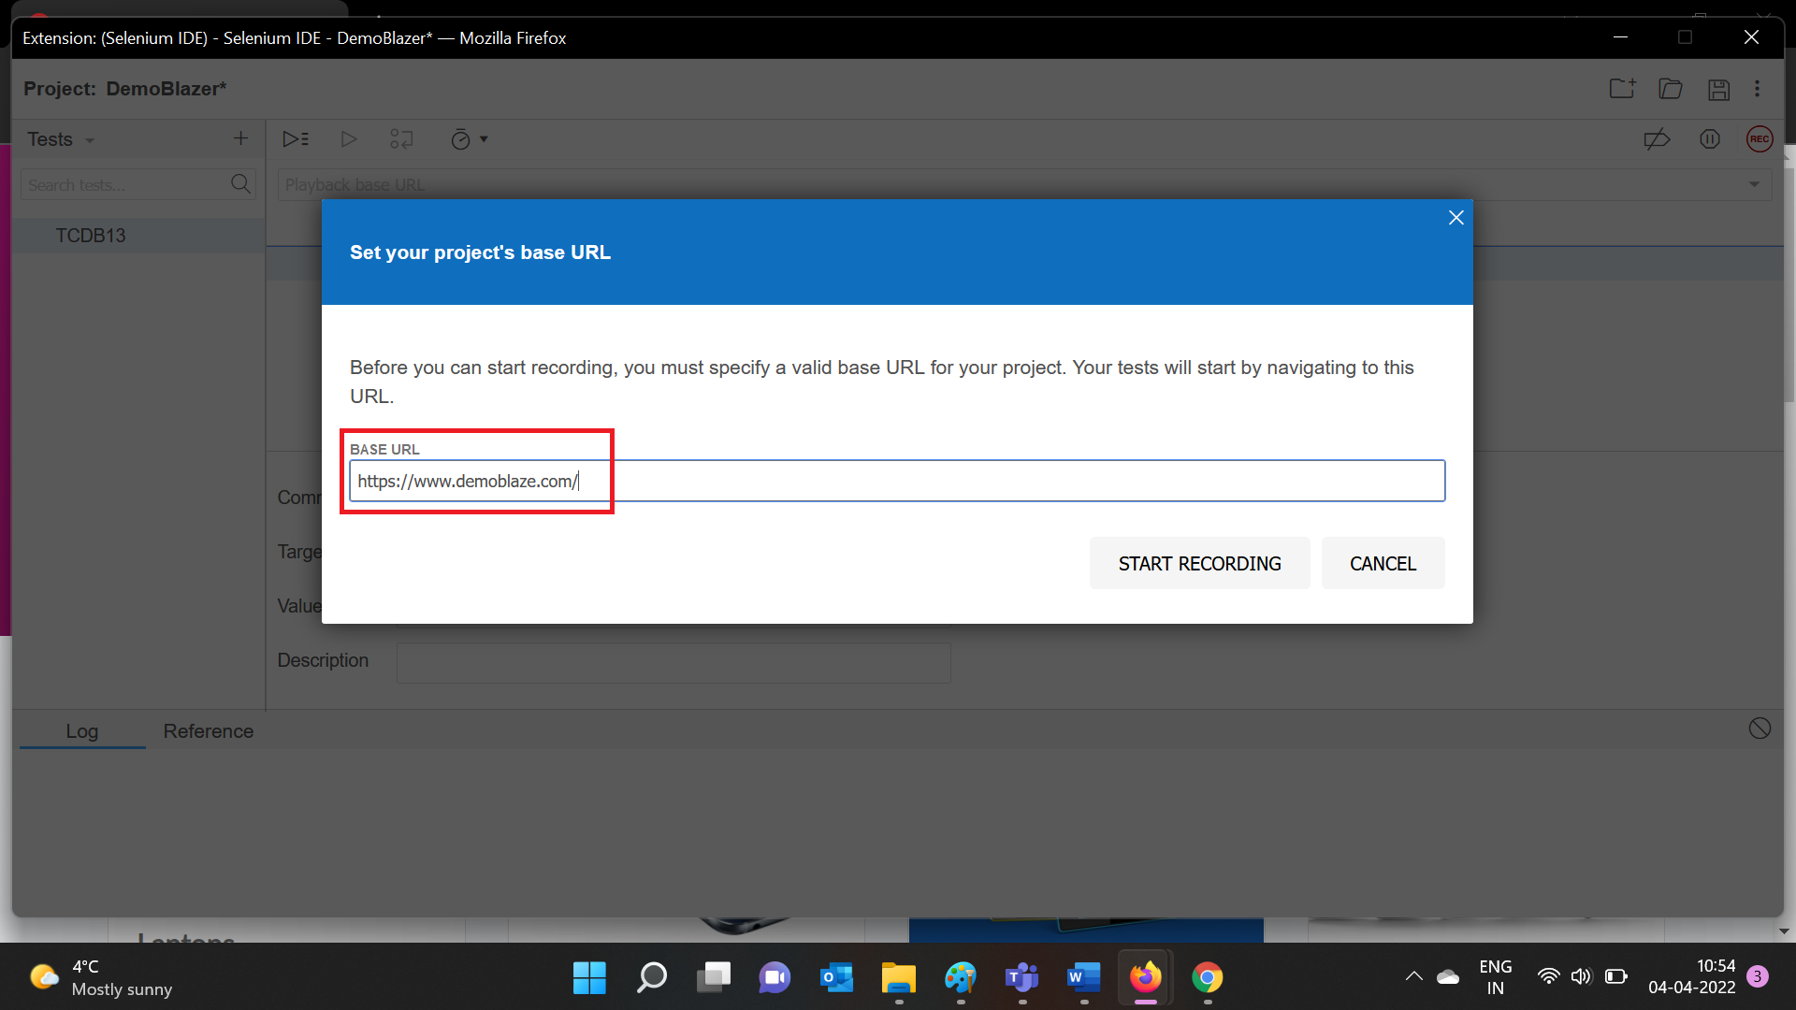

Click on Start Recording:

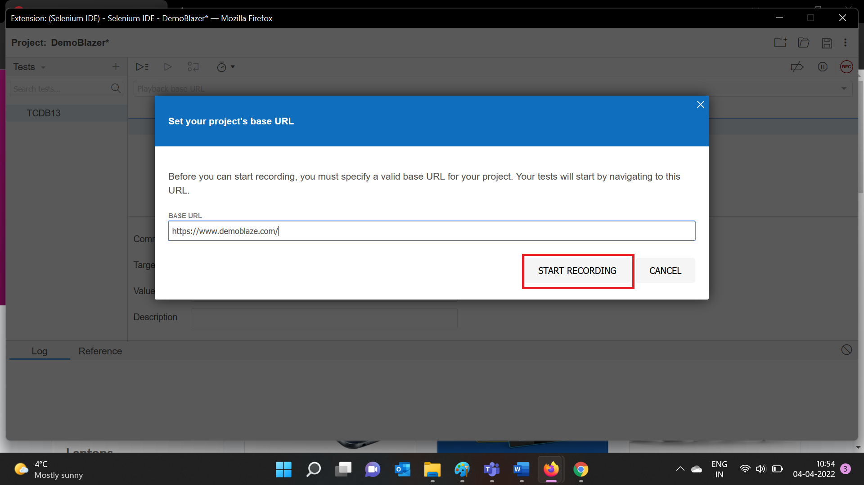

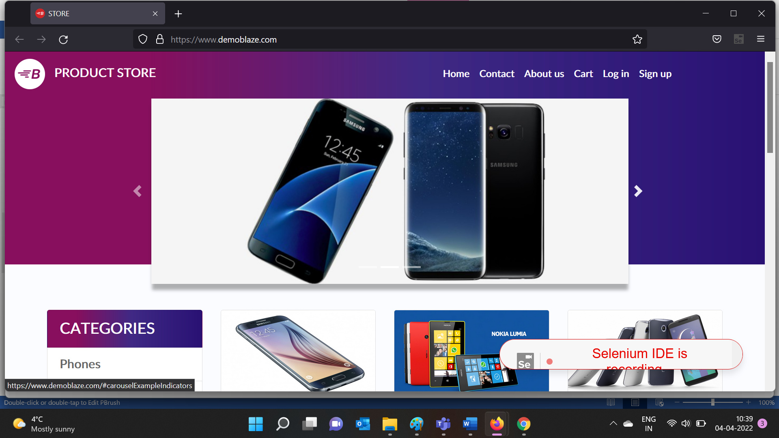

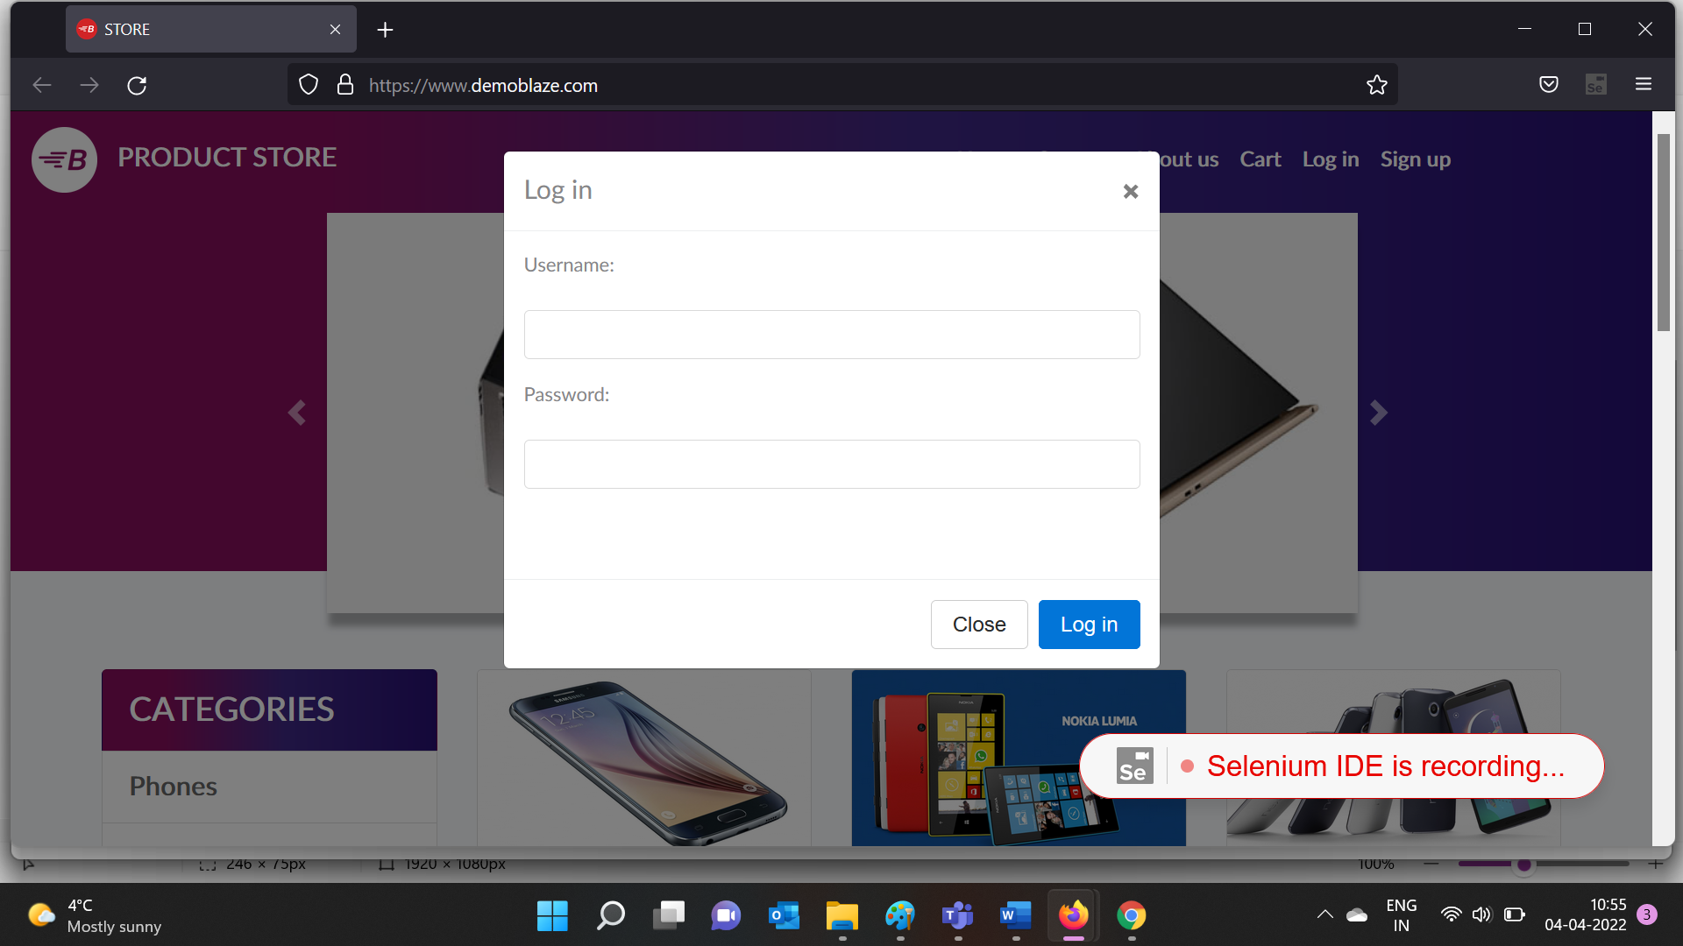

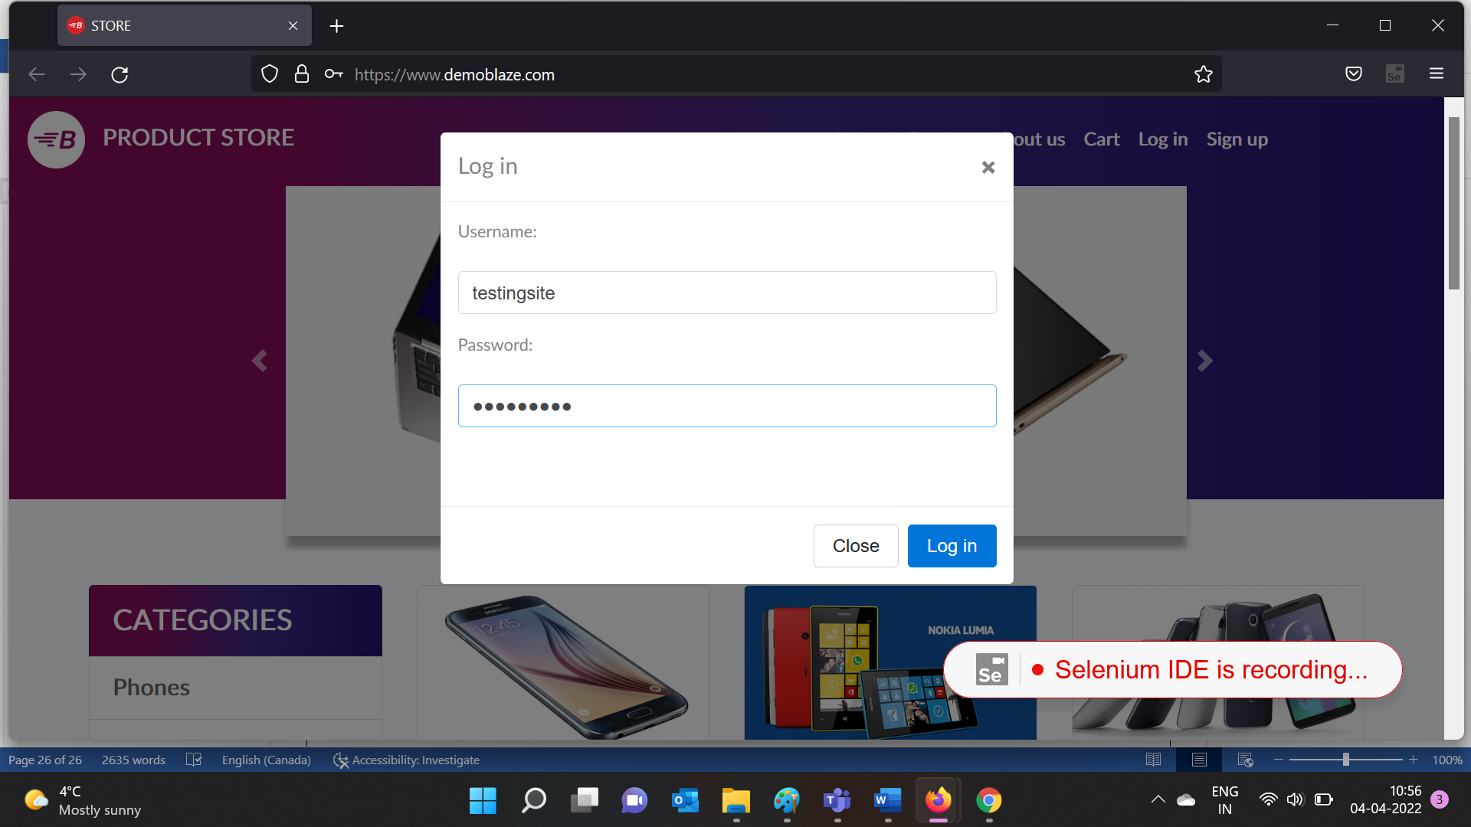

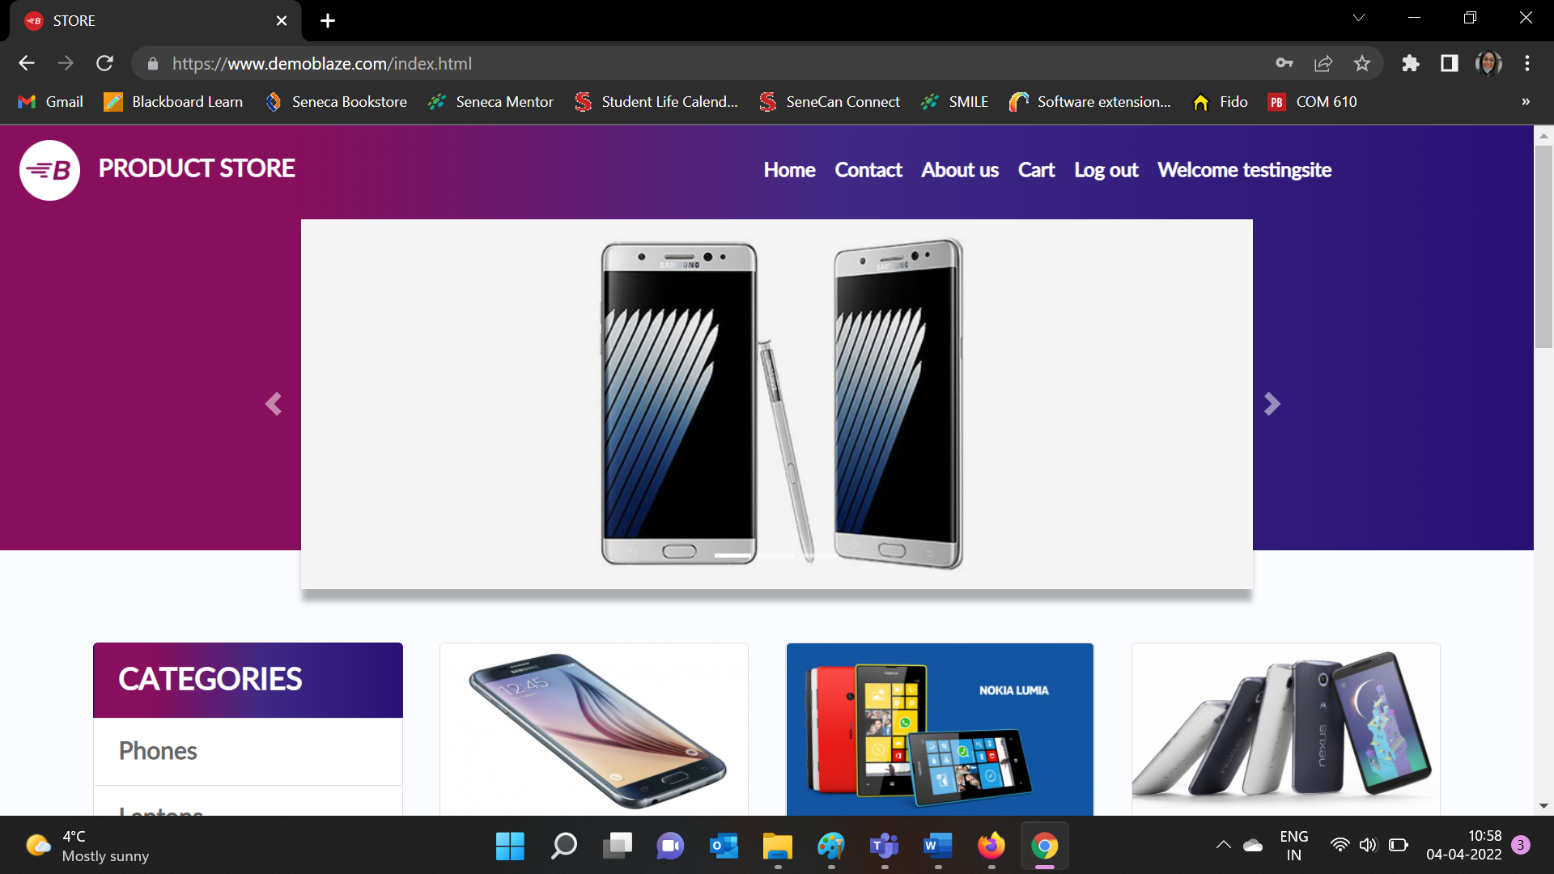

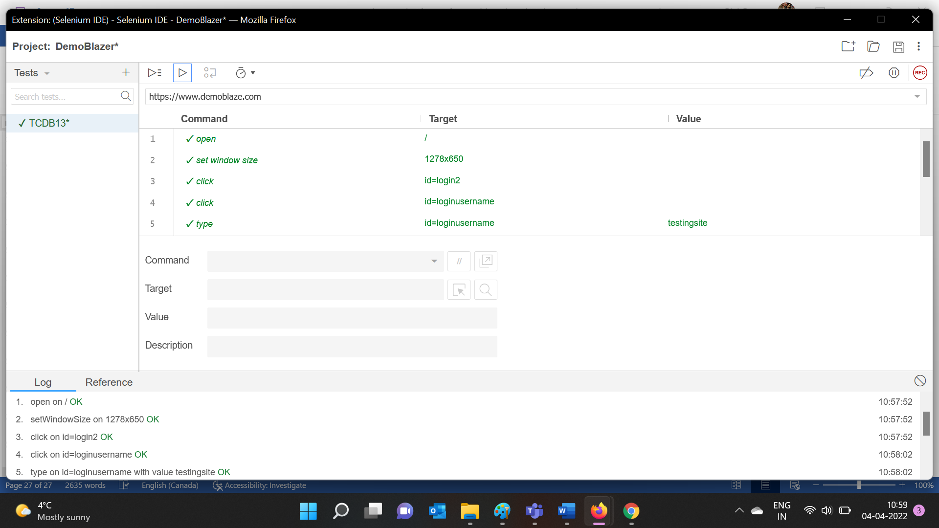

The test is completed successfully:

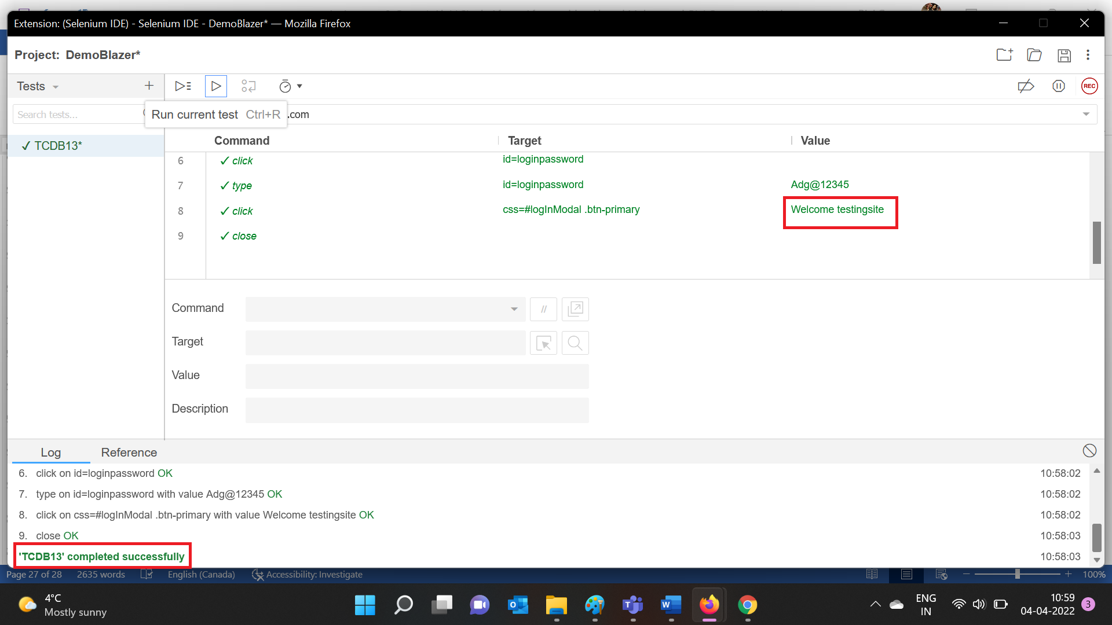

|  |  |
| --- | --- |
| Test Case ID | TCDB11 |
| Test Case Summary | Verify with no usernames and valid password |
| Result | Pass |



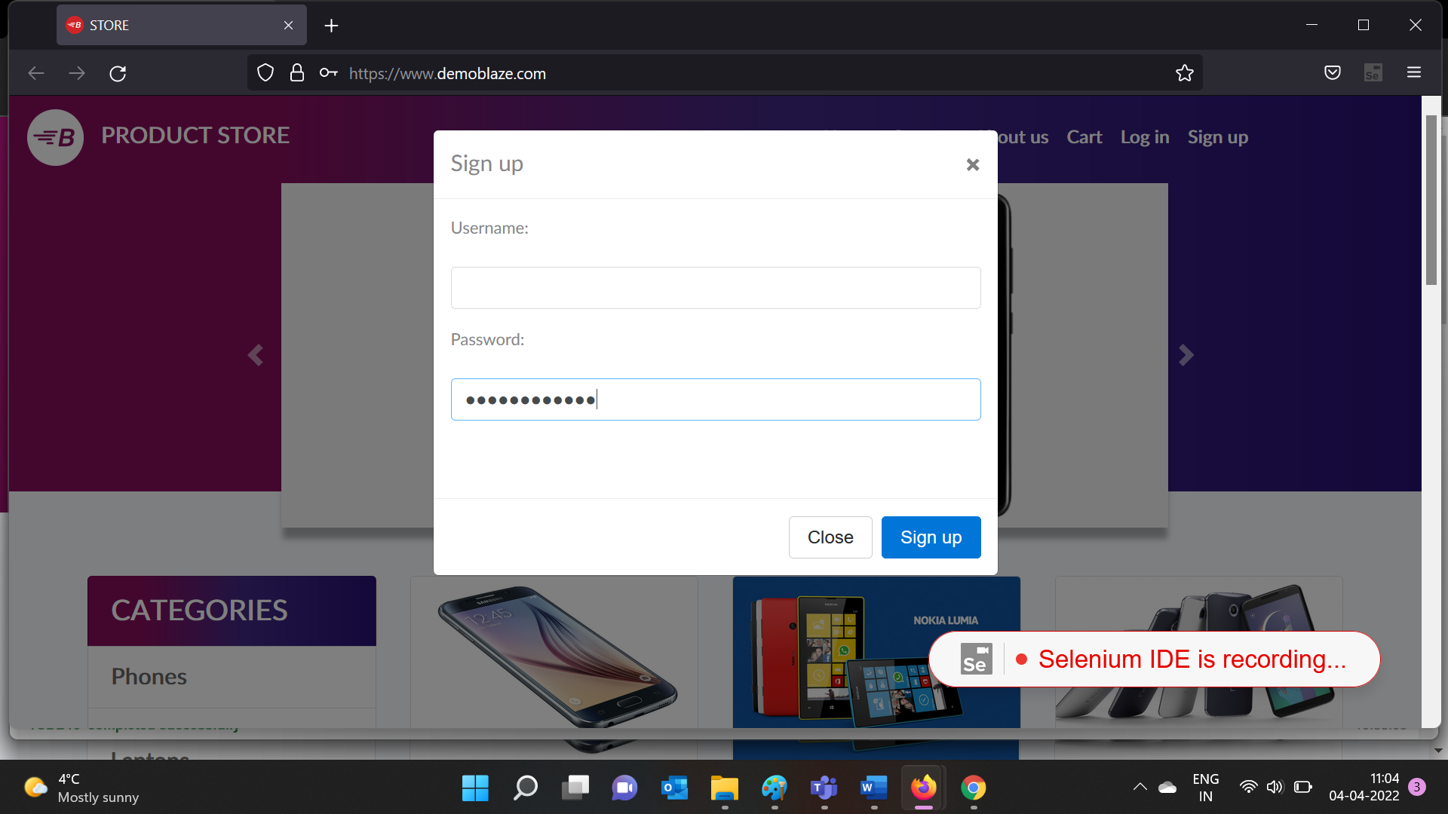

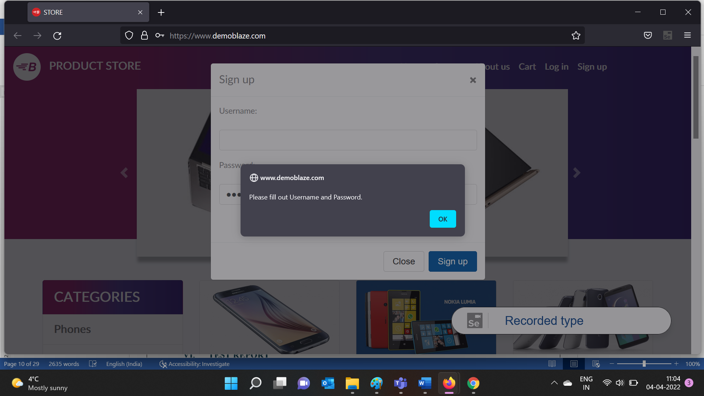

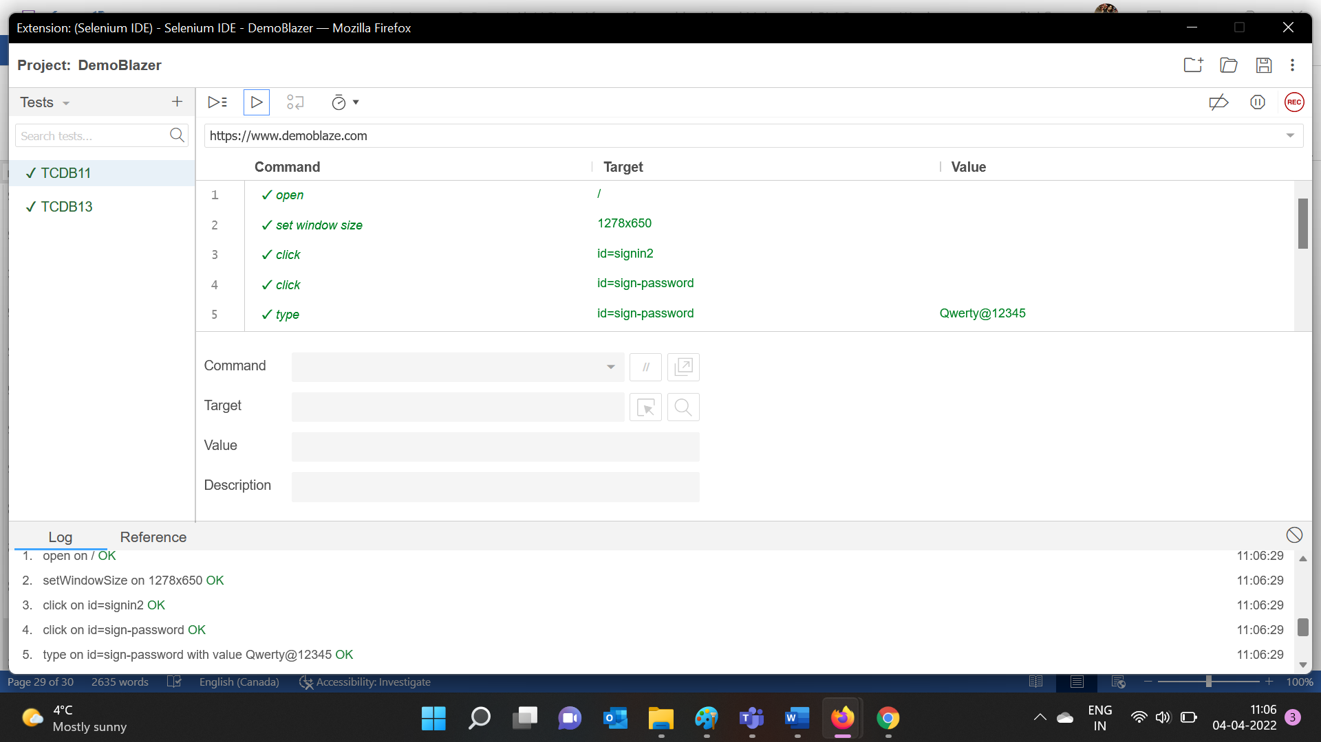

The test was executed successfully:

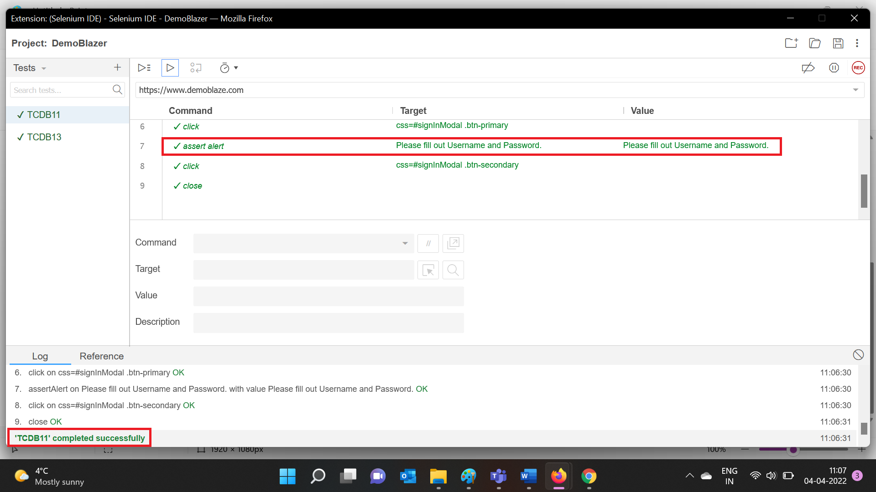

1. **TEST REPORT**

**Manual Test report:**

|  |  |  |  |  |  |
| --- | --- | --- | --- | --- | --- |
| Executed | | | | | Test Planned |
| Passed | Failed | Pending | Blocked | Total | 5 |
| 2 | 3 | - | - | 5 |

|  |  |  |  |  |
| --- | --- | --- | --- | --- |
| Defect s | | | | Total Defects |
| Critical | High | Medium | Total to be fixed | 3 |
| 1 | 2 | - | 3 |

**Automation Test Report:**

|  |  |  |  |  |  |
| --- | --- | --- | --- | --- | --- |
| Executed | | | | | Test Planned |
| Passed | Failed | Pending | Blocked | Total | 2 |
| 2 | - | - | - | 2 |

|  |  |  |  |  |
| --- | --- | --- | --- | --- |
| Defect s | | | | Total Defects |
| Critical | High | Medium | Total to be fixed | 0 |
| - | - | - | 0 |